!! LETTER TO THE NEWS MEDIA AND PUBLIC !!

First, I would like to publicly thank the Monroe Free Press for their news article dated December 27, 2025. Paster wages the longest civil rights fight in local history, after 38 years still denied trial. The article informs the public that judges, politicians, and those in power ignore us and the law. What are their motives for not carrying out the order of court of appeal?
Before Court of Appeal, my case went before former Judge Garland Smith, who’s also a Baptist preacher here in Monroe, La. The city attorney was J. Rodney Pierre. Both men are of African American descent as I.
Court of Appeal: Judgement was rendered on September 23, 1998, before Williams, Stewart and Gaskins, JJ. The Order State “That I the defendant, Lester Paster, was charged with a violation of La. R.S. 14:401” which means this case belongs to the State District Court and never should have been held in Monroe City Court.
Court of Appeal:” In briefs submitted to this court, both appellant and appellee argued whether Mr. Paster violated Monroe City Ordinance 12:186 which prohibits demonstrations at courthouses or residences of jurors, or witnesses. However, the only charging document contained in the record reflects that Mr. Paster was charged with a violation of La. R.S 14:401”. Judge Garland Smith and City Attorney Rodney Pierre intentionally changed the charges, knowing they were breaking the law.
The change of charge from La. R.S:14:401 to Monroe City code 12:186 does not show on the transcripts of the case, even though this change was made while court was in session. I also need the reader to know, that at the court arrangement, Judge Garland Smith first word was, “what is this matter about?” City Attorney Pierre stated, “passing out paper on Judge Sharp”. These statements are not shown on the transcript of the case. I can prove this statement was made while court was in session.
- The first document Court Arrangement does not show Monroe City Court entered a charge of La. R.S 14:401 or Monroe City Ordinance 12:186
- The Second Document is The Court Trial Page #18, Closing argument, I reminded Judge Smith and City Prosecutor Pierre about the statement about passing out papers on Judge Sharp. City Prosecutor did not challenge Mr. Pasters statement on Judge Sharp.
- These Statements should have been the first Statements made at the Court Arrangements. And it’s not Present. TAMPERING WITH TRANSCRIPS ARE AGAINST THE LAW !!!!
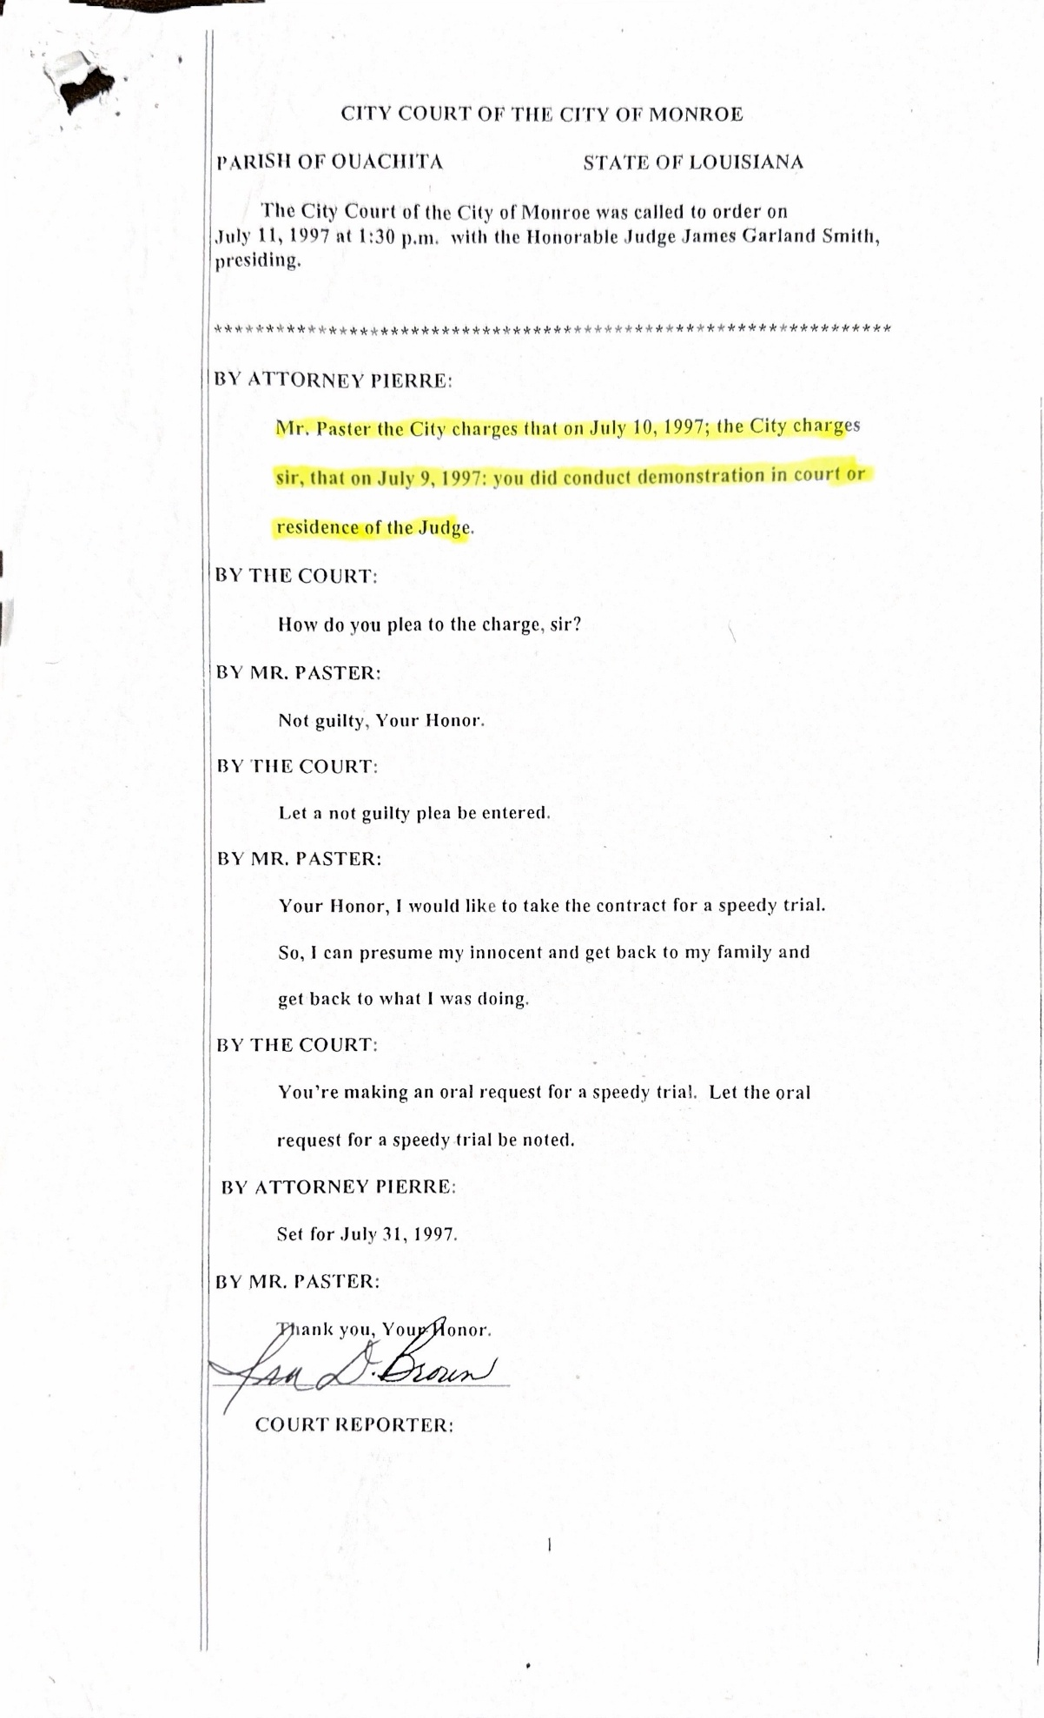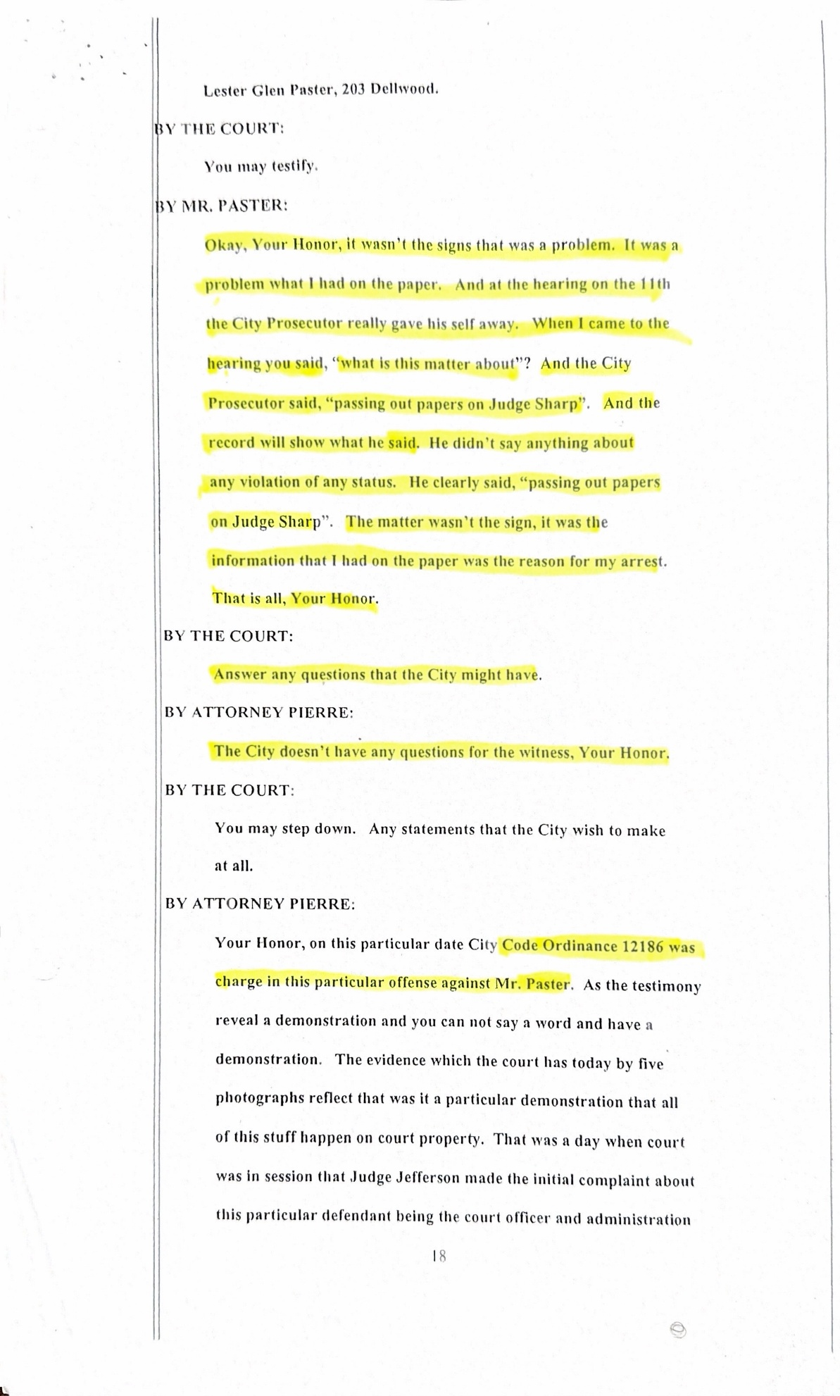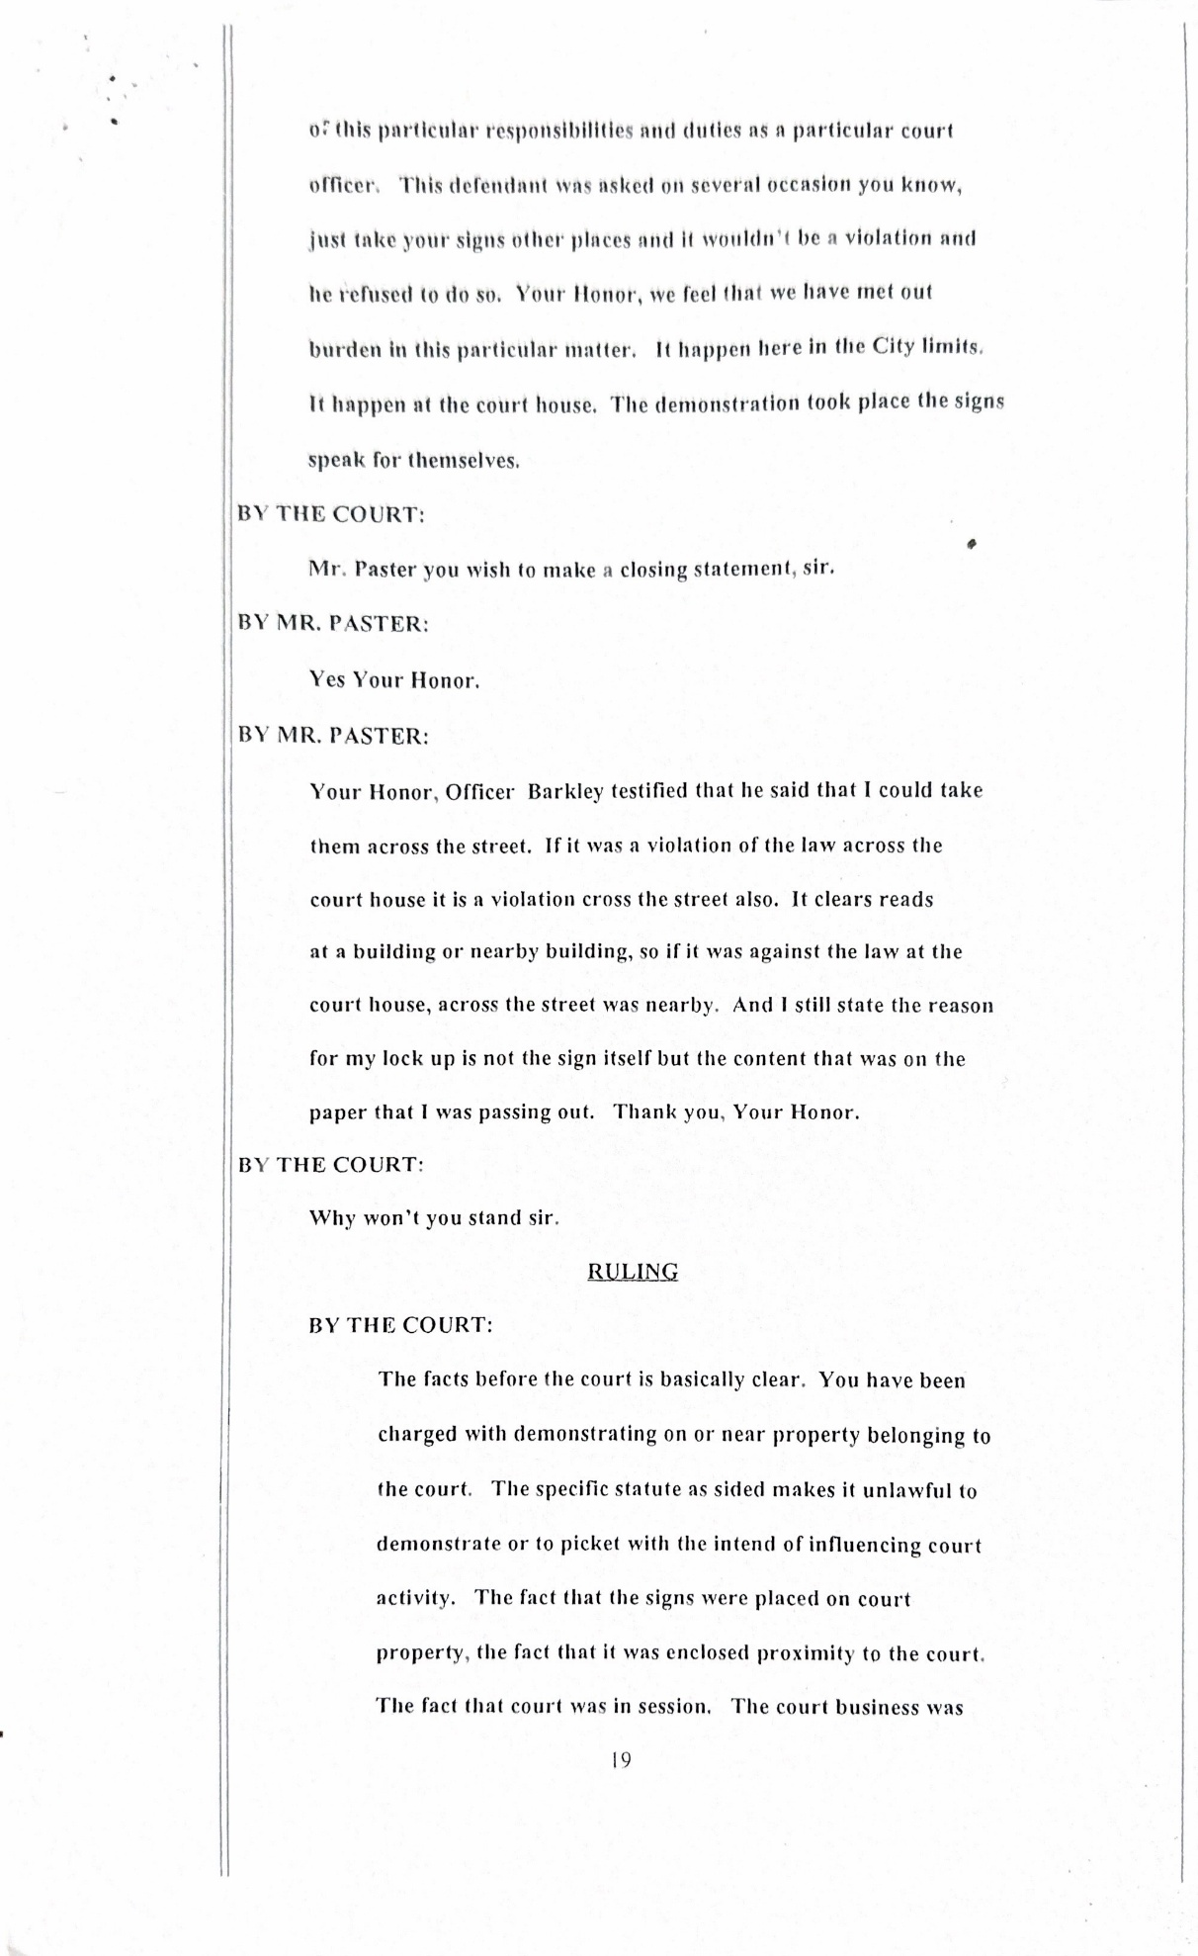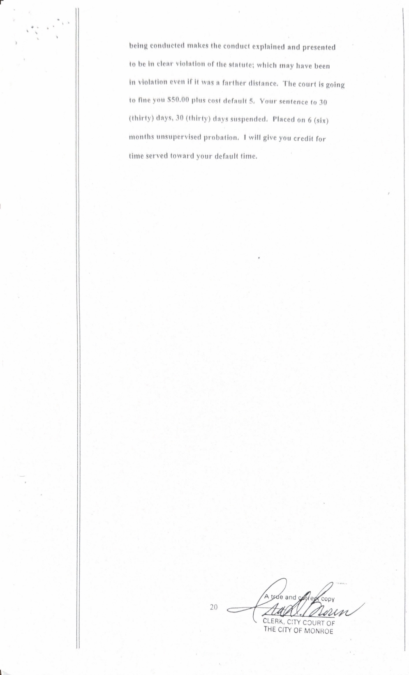

Court of Appeals:” Finding error patent because there was no advisement of right to jury or right to counsel and no waivers of either of these constitutional rights, we reverse and vacate the conviction and sentence and remand for new proceeding”. New proceedings have not taken place as order by the Court of Appeal. Monroe City Clerk of Court Office continues to state that the order of court appeal got burned up in the fire, this is just one of the reasons that the government uses for not carrying out the order of court of appeal. 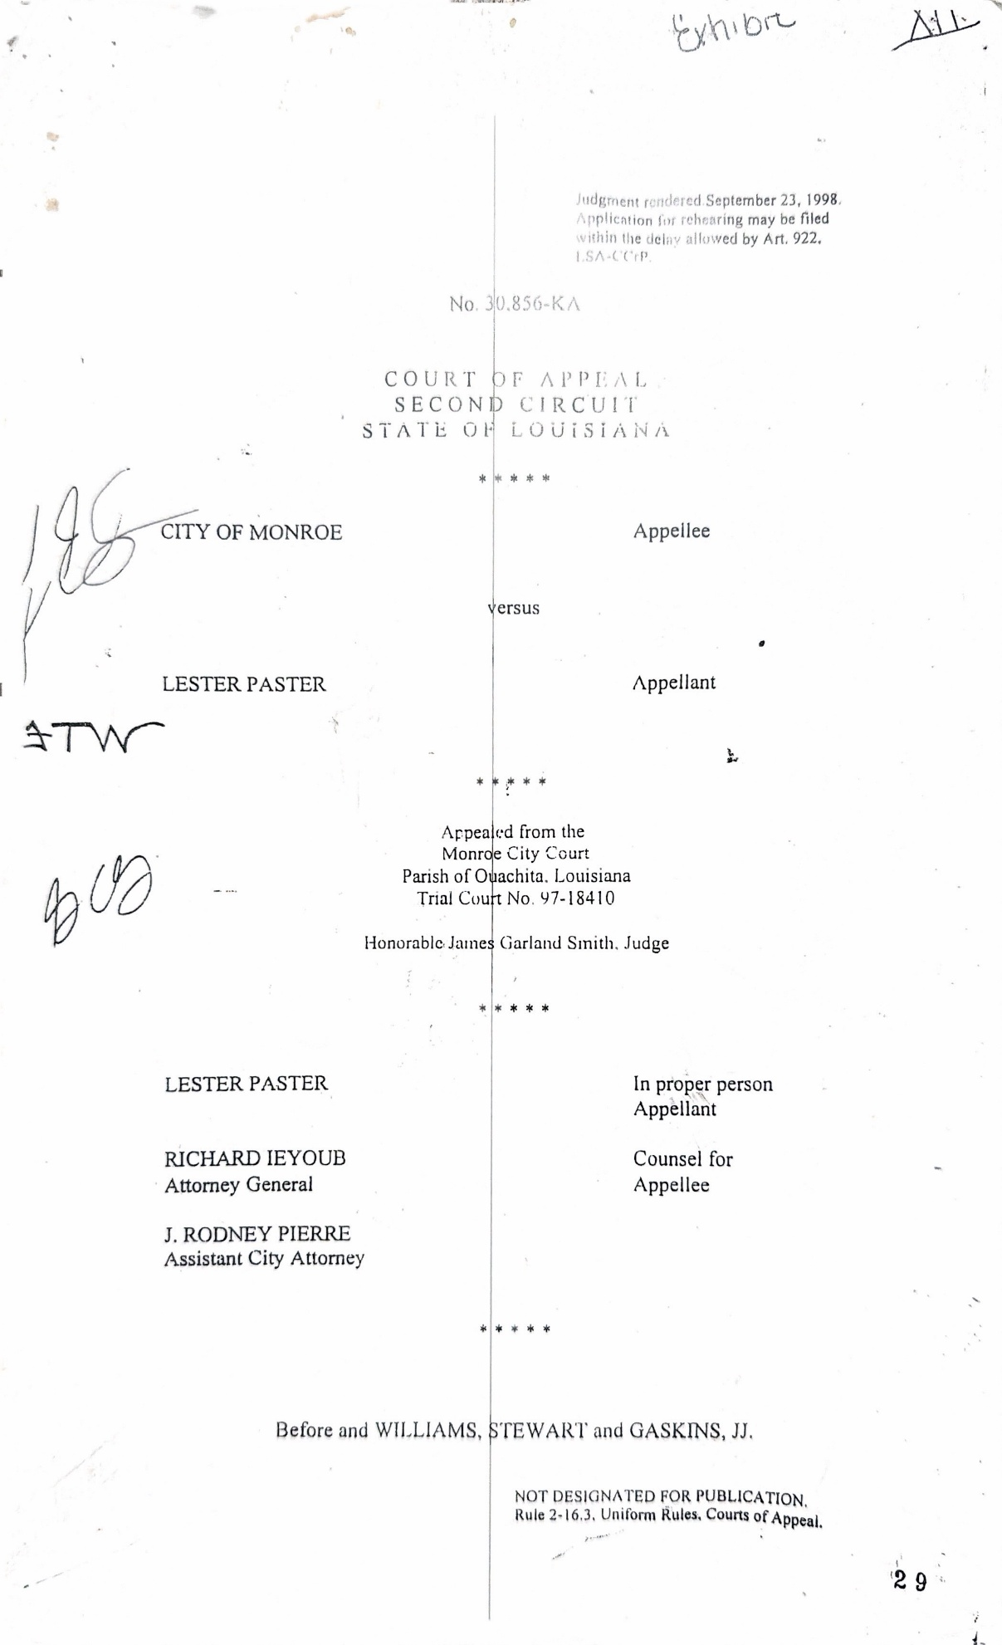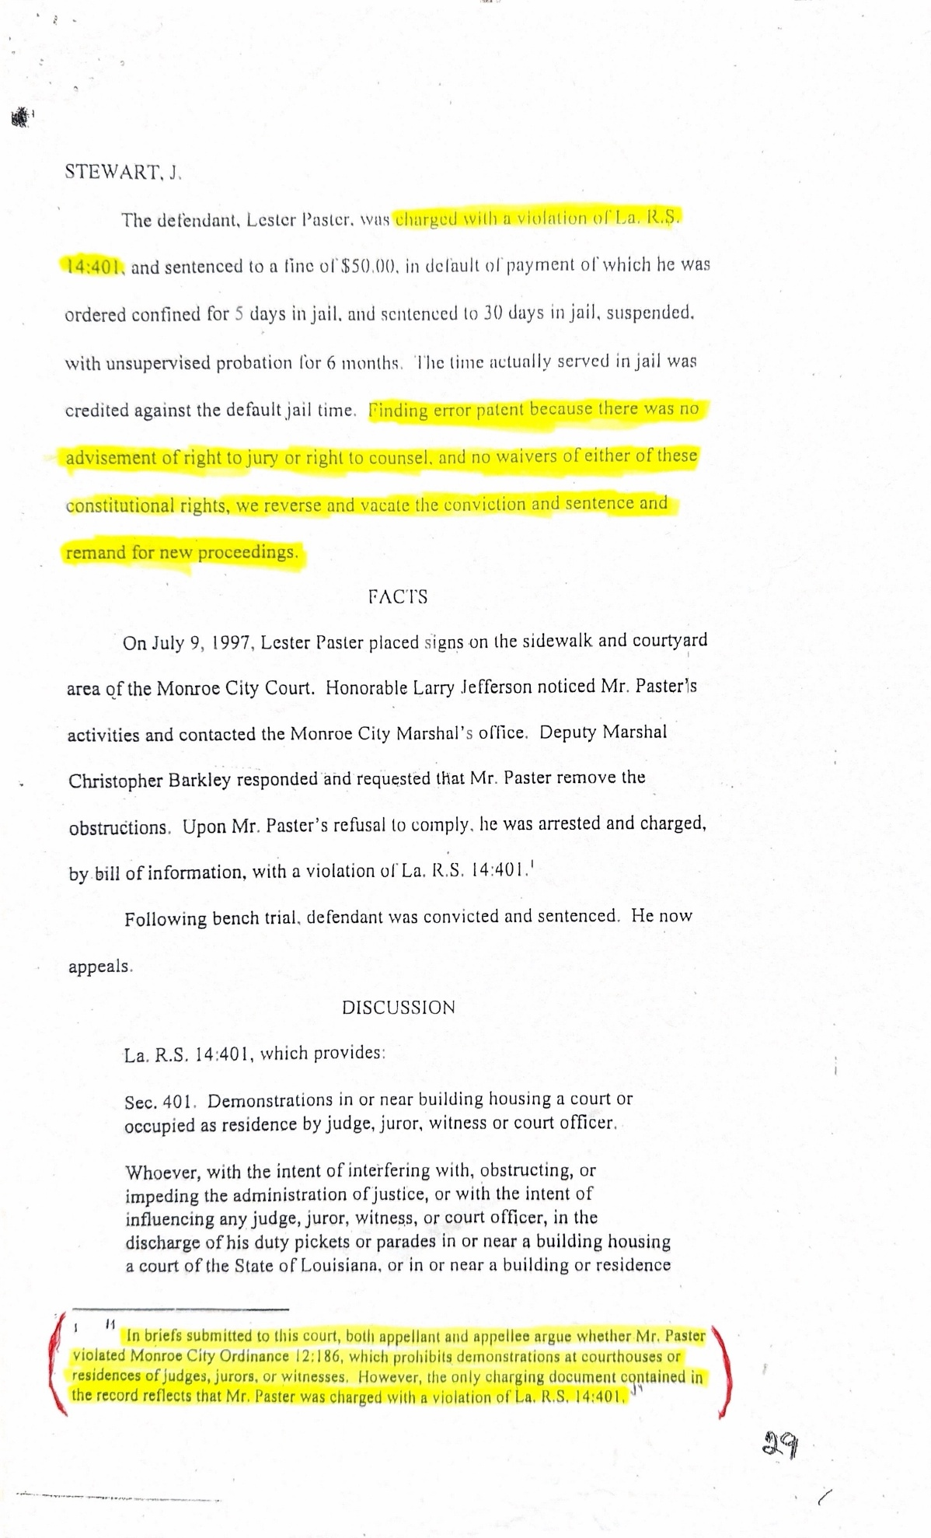
Court of Appeal: On December 22, 1997, this court, noting the inadequacy of the record to show the waiver of right to counsel of jury trial, ordered the record supplemented with any minutes of court or transcript relating to the waiver of either of these rights. The supplementation received shows no waiver. The record in this case does not show that the appellant was advised of his right to trial by jury or waived that right. It also does not show that he was advised of his right to counsel or intelligently and voluntarily waived that right. The failure of the record to show advisement and waiver of these constitutional rights is error patent on the face of the record and mandates reversal and remand for new proceedings.”
Court of Appeal: Nothing in this section shall interfere with or prevent the exercise by any court of the State of Louisiana its power to punish for contempt.

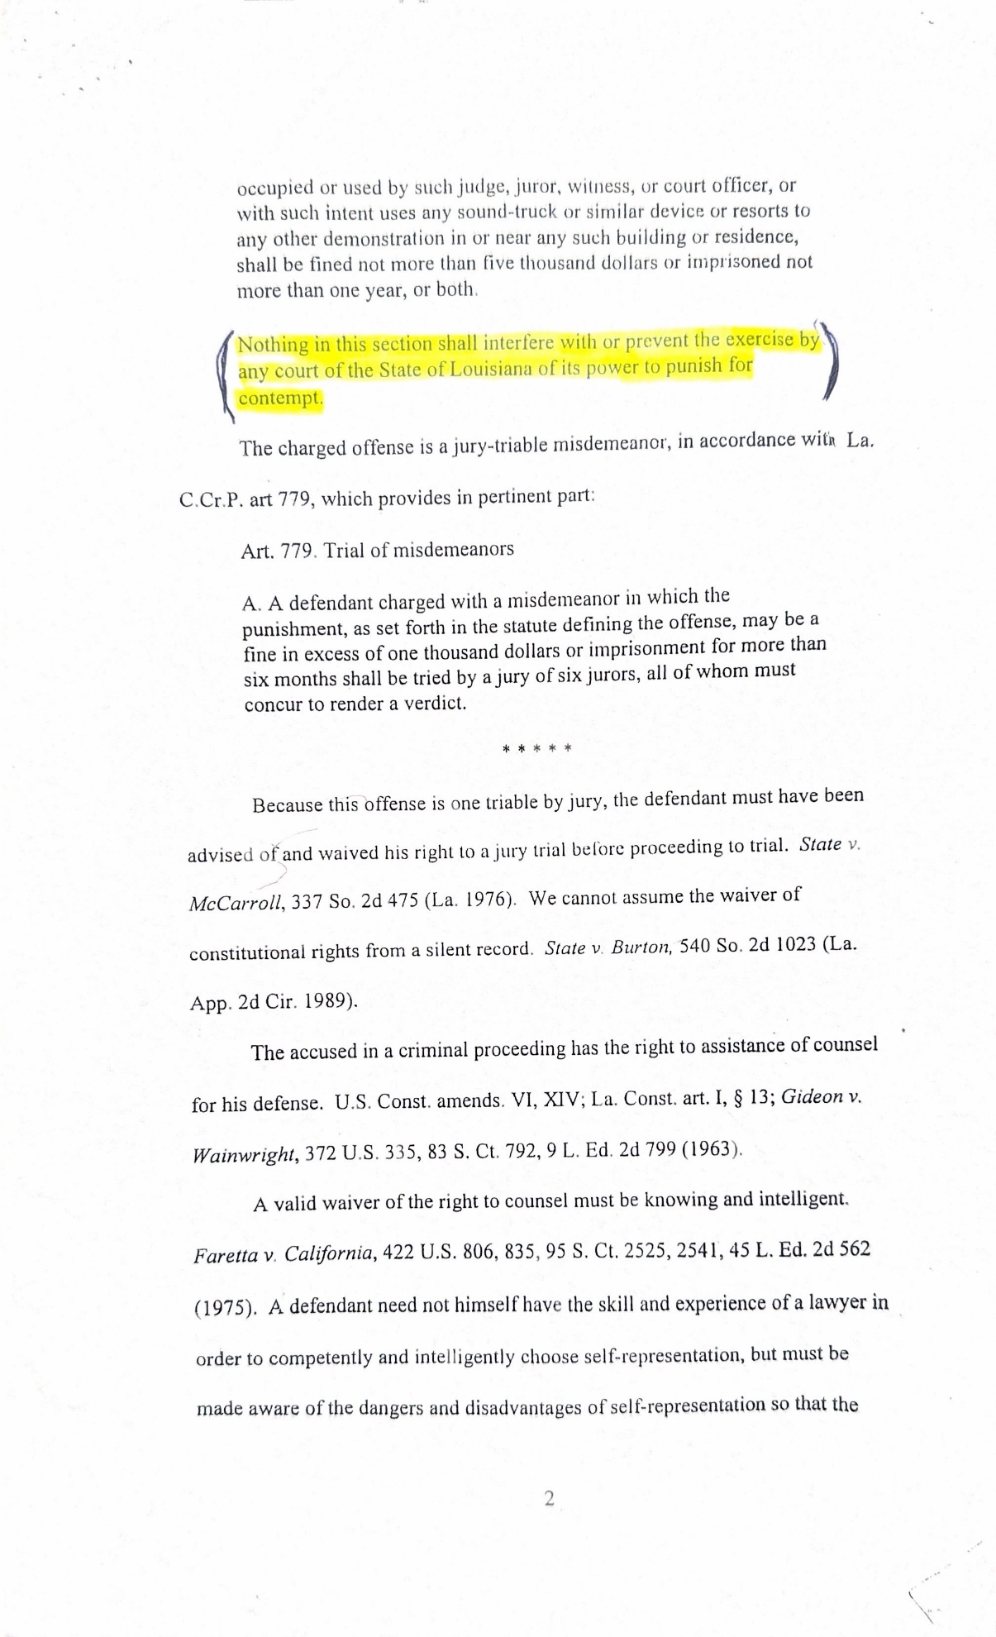

.
You have the right to say that Mr. Lester Paster needs to get him an attorney. Court of Appeal stated under La. R.S.14:401 Mr. Paster has the right to counsel, and jury trial. The State of Louisiana should obey the court order, as it is required for everyone else to obey court order.
Court of Appeal: DECREE For the reasons explained, we set aside defendants’ conviction and sentence and remand the case to city court for further proceedings consistent with this opinion. REVERSED and REMANDED.
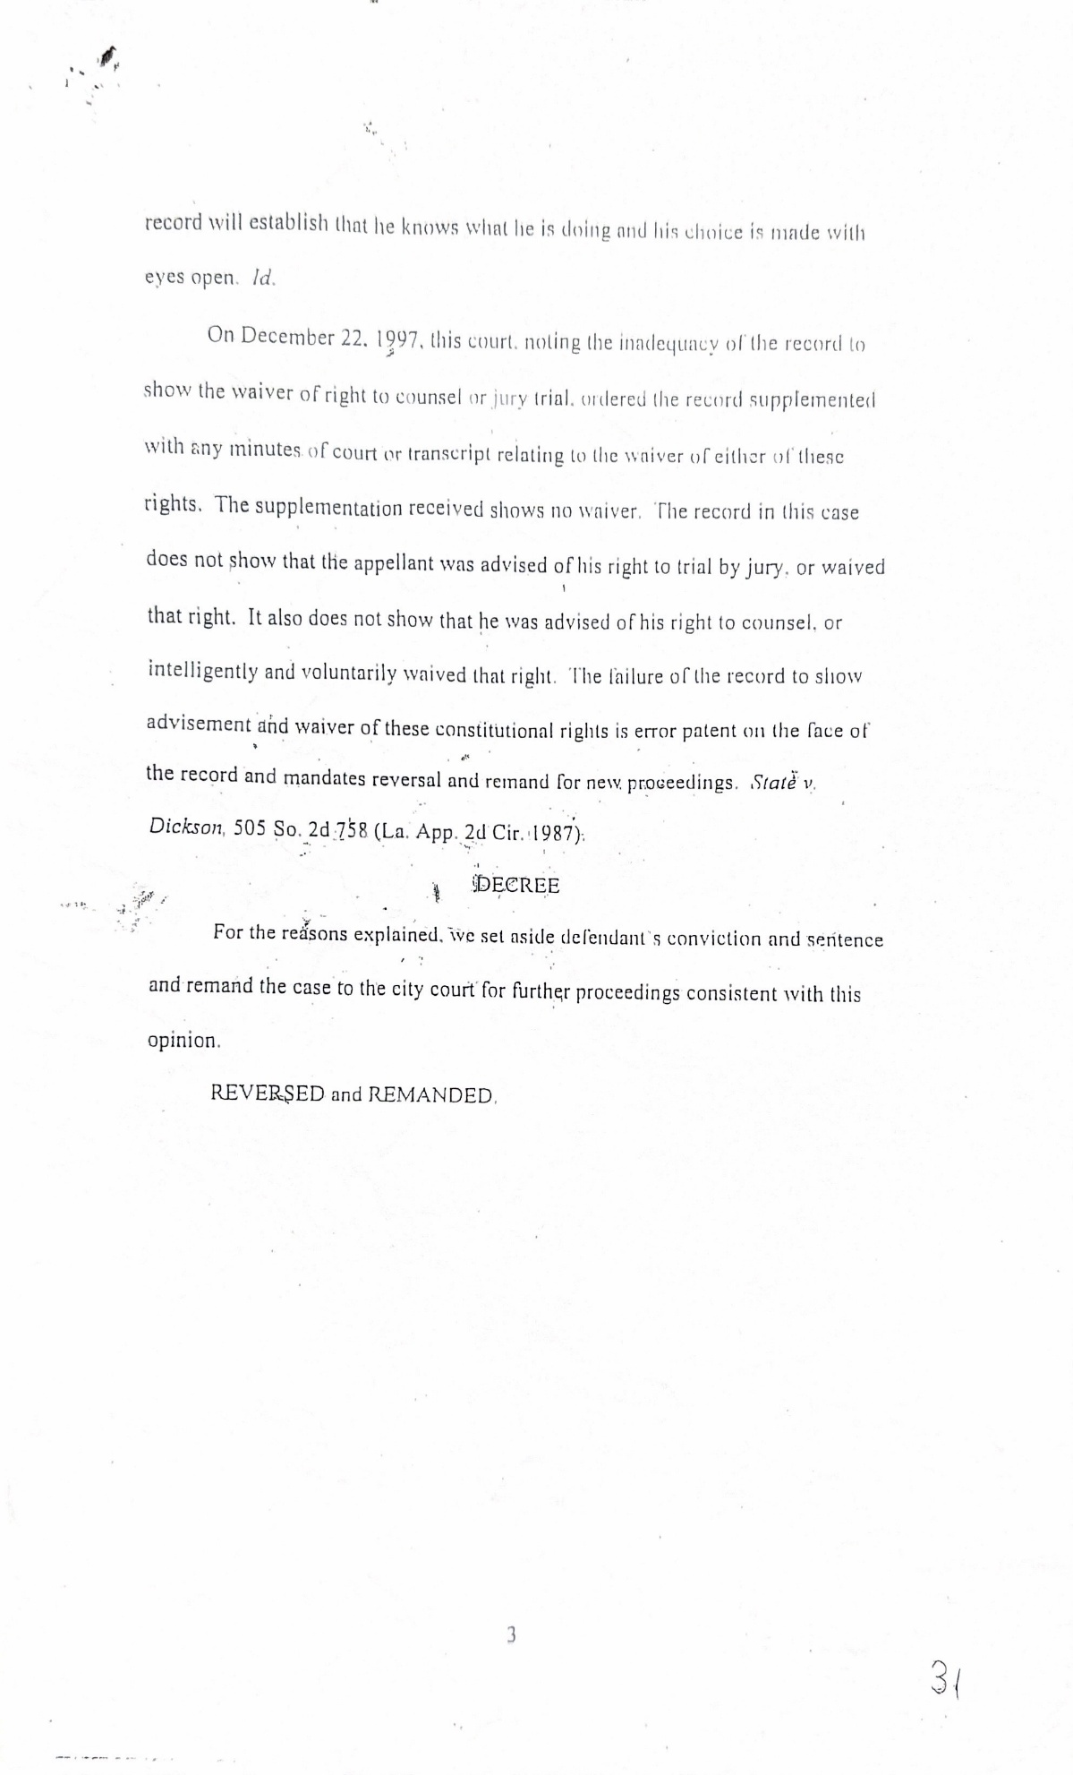
Motive and reason: why would former Judge Garland Smith, a highly respectable preacher and City Attorney Rodney Pierre violate, their oaths of offices? In the Summer of 1987, I protested at a workplace discrimination, in front of an auto parts store. The protest lasted about ninety-seven days. I was arrested on three different occasions for posting signs on city right of way, but I was never arranged for court. On the third arrest, I was gagged with ammonia. I escaped out of jail but was captured and held in jail, without bond. After four days, I was released without been arranged for trial Again.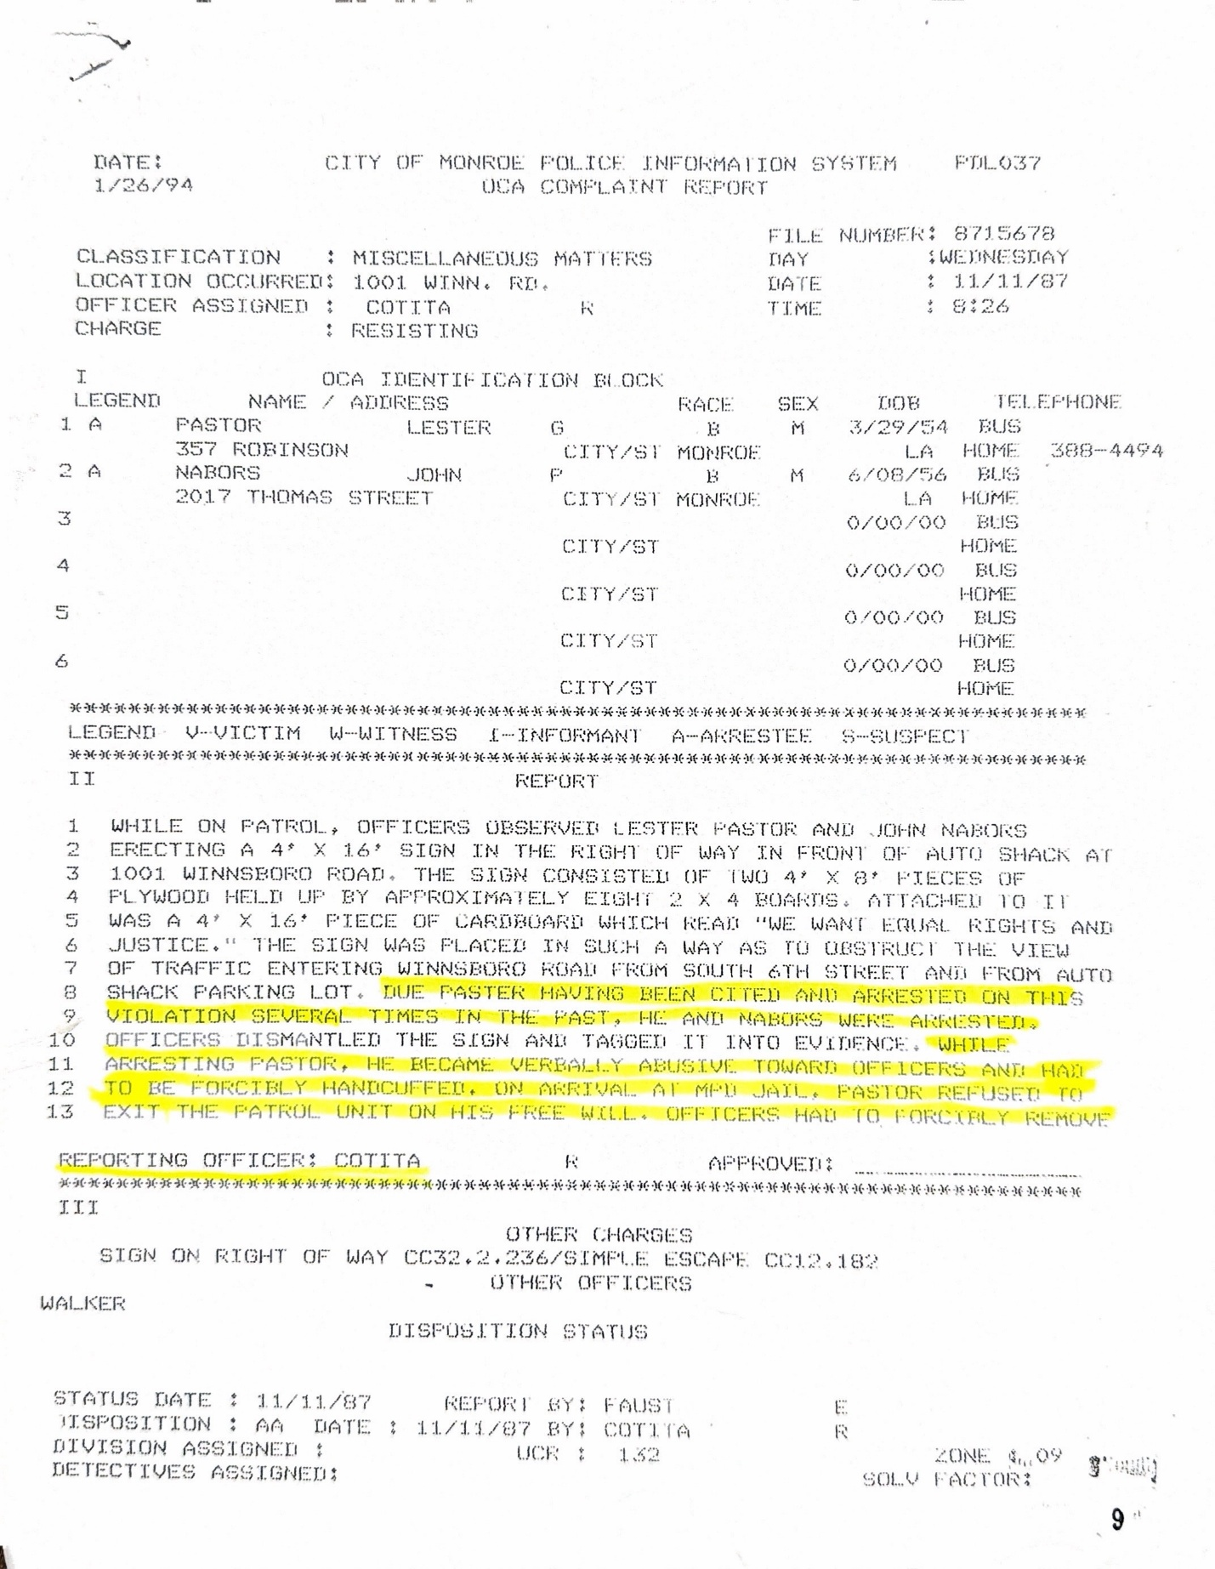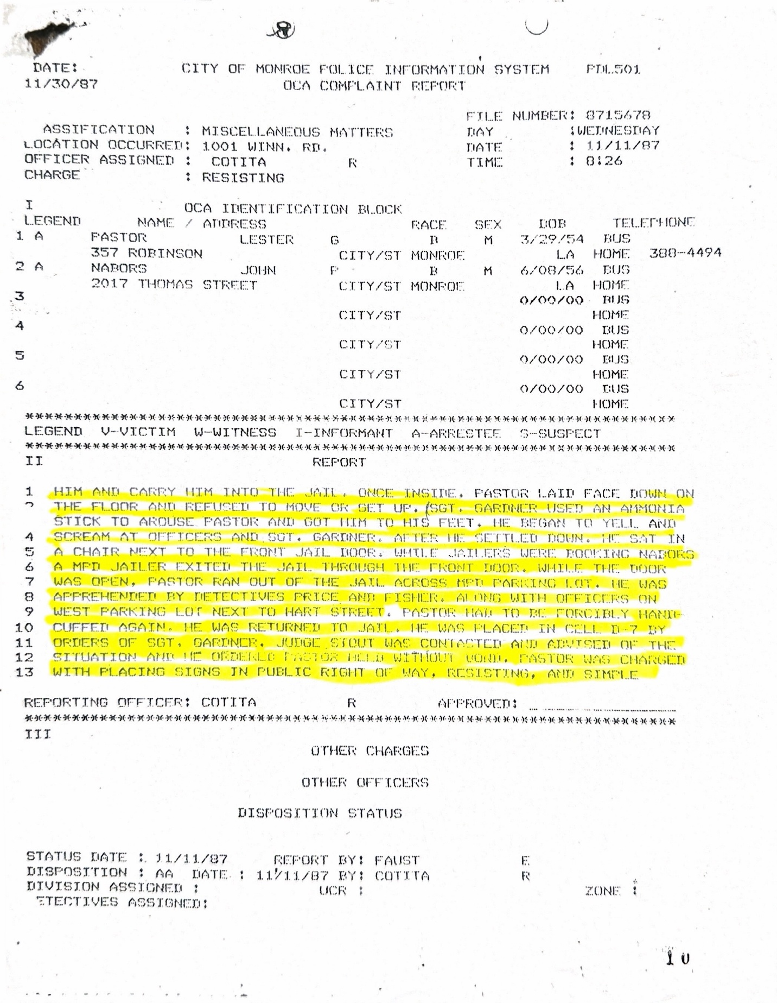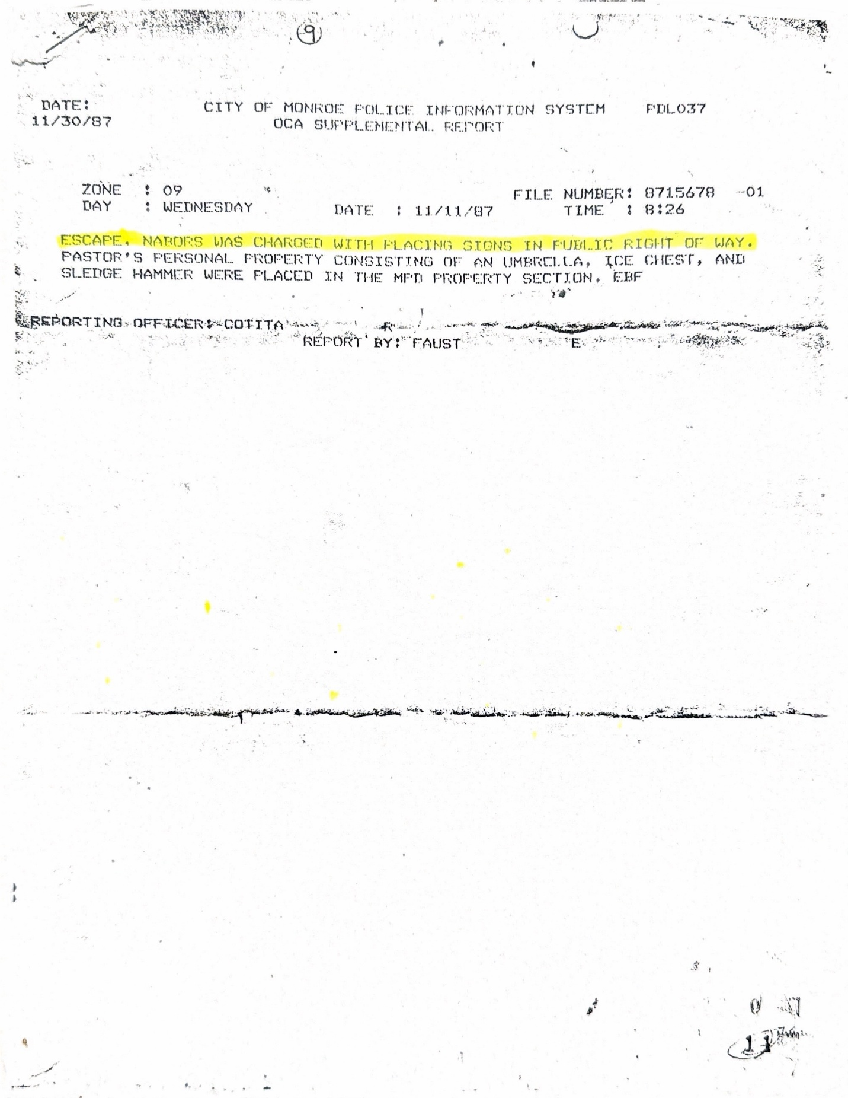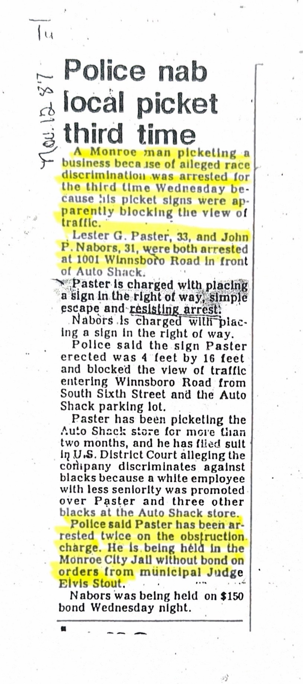

After the protest was over, City Attorney Carl Sharp, at that time, refused to arrange me for court, for the three different arrests, his friend Attorney Clyde Lain called and spoke with me. He stated, that “I can get you a court date and beat all charges.” He calls me back stating “I have a court date for you.” before court starts, Attorney Clyde Lain comes from the back and states, “Carl is willing to drop all charges except one.” I refused. Attorney Lain went back to the back, then came back to me and said, “Carl will get back with us.”
Attorney Clyde Lain did not contact me, so I contacted him. He stated not to worry about it. I stated “that’s crazy and left his office. Protest cotinine. Free Press Newspaper prints a front-page news story titled, “Paster angry, says he can’t get a trial after nearly three years.”
Page two of this news article. FREE PRESS: “Exactly Why Paster’s case has never come to trial is not known, but Lester Paster says he won’t give up his fight until his name is cleared and the actions of the officers are investigated. “Sharp said Tuesday that as far as his office is concerned, the charges against Paster are dropped. He said his office did not prosecute the charges because they were minimal, and he decided to let the time lapse. As for the officers involved in Paster’s arrest, Sharp says that is beyond his department.”
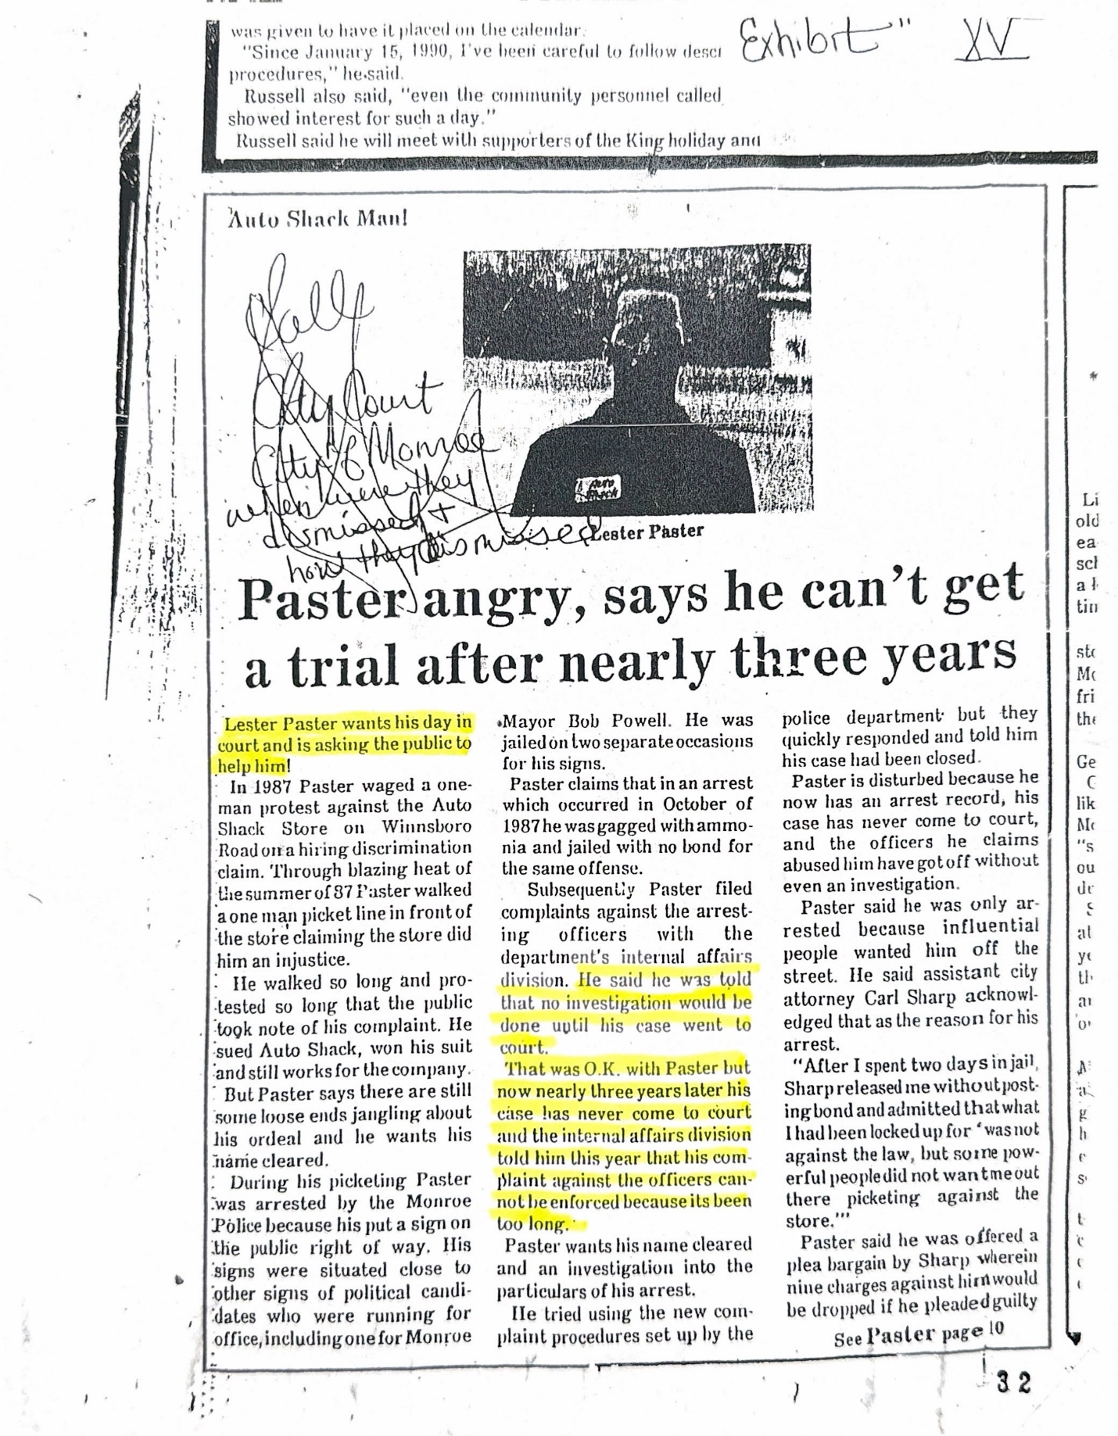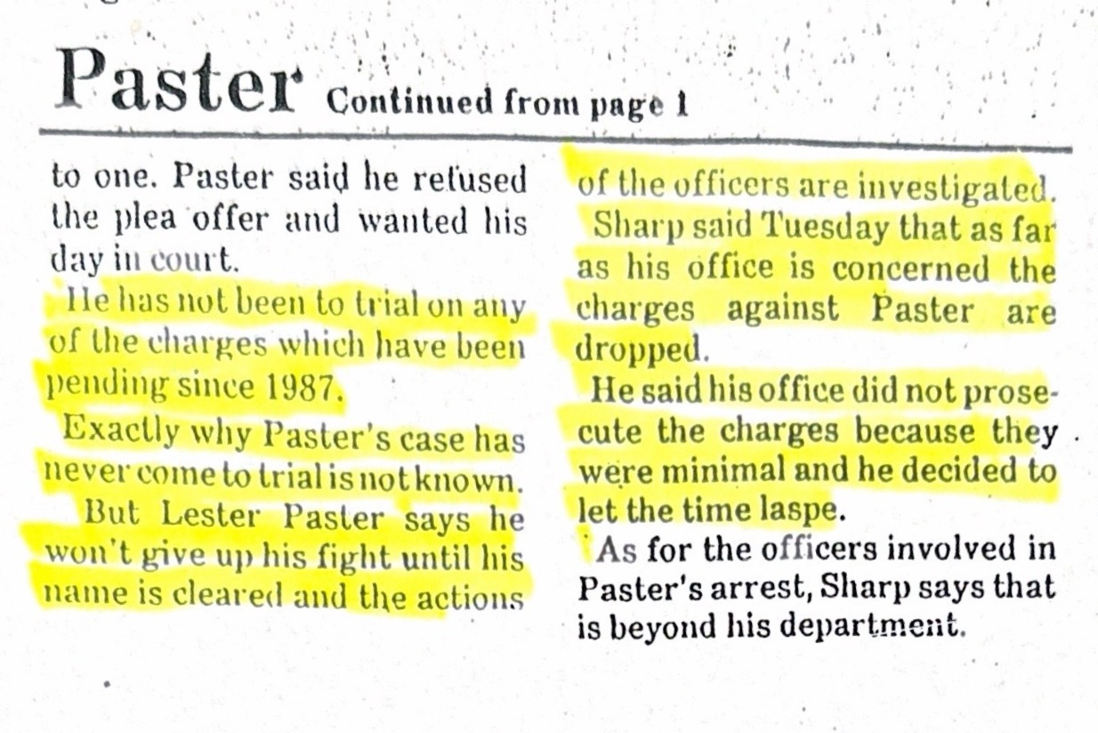

Protests continue, and after not being able to find an attorney in City of Monroe, I crossed state lines and hired an Attorney by the name of Chokwe Lumumba. To his findings, he asked how I could be arrested three times, gagged with ammonia, escaped from jail, and not be giving due proceeding of the law. Attorney Lumumba took the case for twenty-five hundred dollars.
Approximately two weeks later, Attorney Lumumba contacted me, to inform me that I could get my money back. Because my case has already been taken to court. I informed him to keep the money so they can prove that this case has already been to court. Weeks later, Attorney Lumumba called me, stating that an attorney by the name of Clyde Lain had taken my case to court. I told him to send me the proof.
I immediately called Attorney Clyde Lain and stated to him what my attorney had informed me of. Attorney Clyde Lain stated there is no way, I can go to court without you been there. I asked him if he would sign an affidavit stating that he did not take my case to court. Attorney Clyde Lain stated yes, have your Attorney to call me. Attorney Clyde Lain later became ill. After he recovered, I received his affidavit.
Affidavit of Attorney Clyde Lain. FILE # 8714142 & 8714690. Affidavit: I do not recall ever entering a plea of nolo contendere on behalf of Mr. Paster but if said plea was in fact entered, I would have discussed this with Mr. Paster. On the first page of the affidavit is stamp, JOHN LARRY LOLLEY JUDGE, DIVISION B MONROE CITY COURT. This case was held in his court room. The Notary Public is Attorney Harvey R. Lexing.
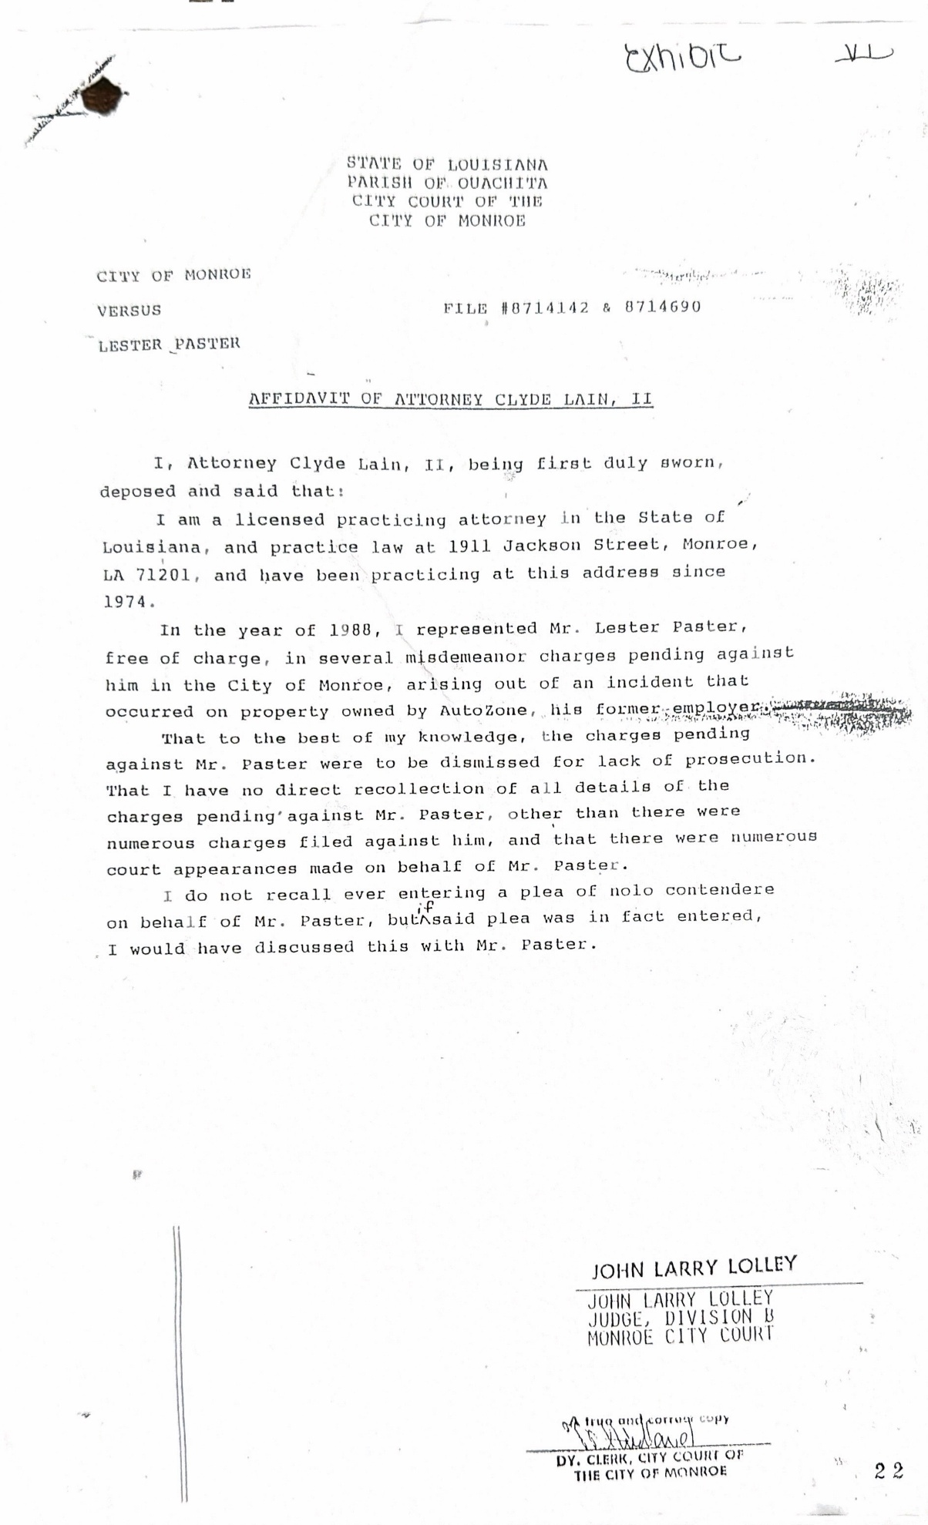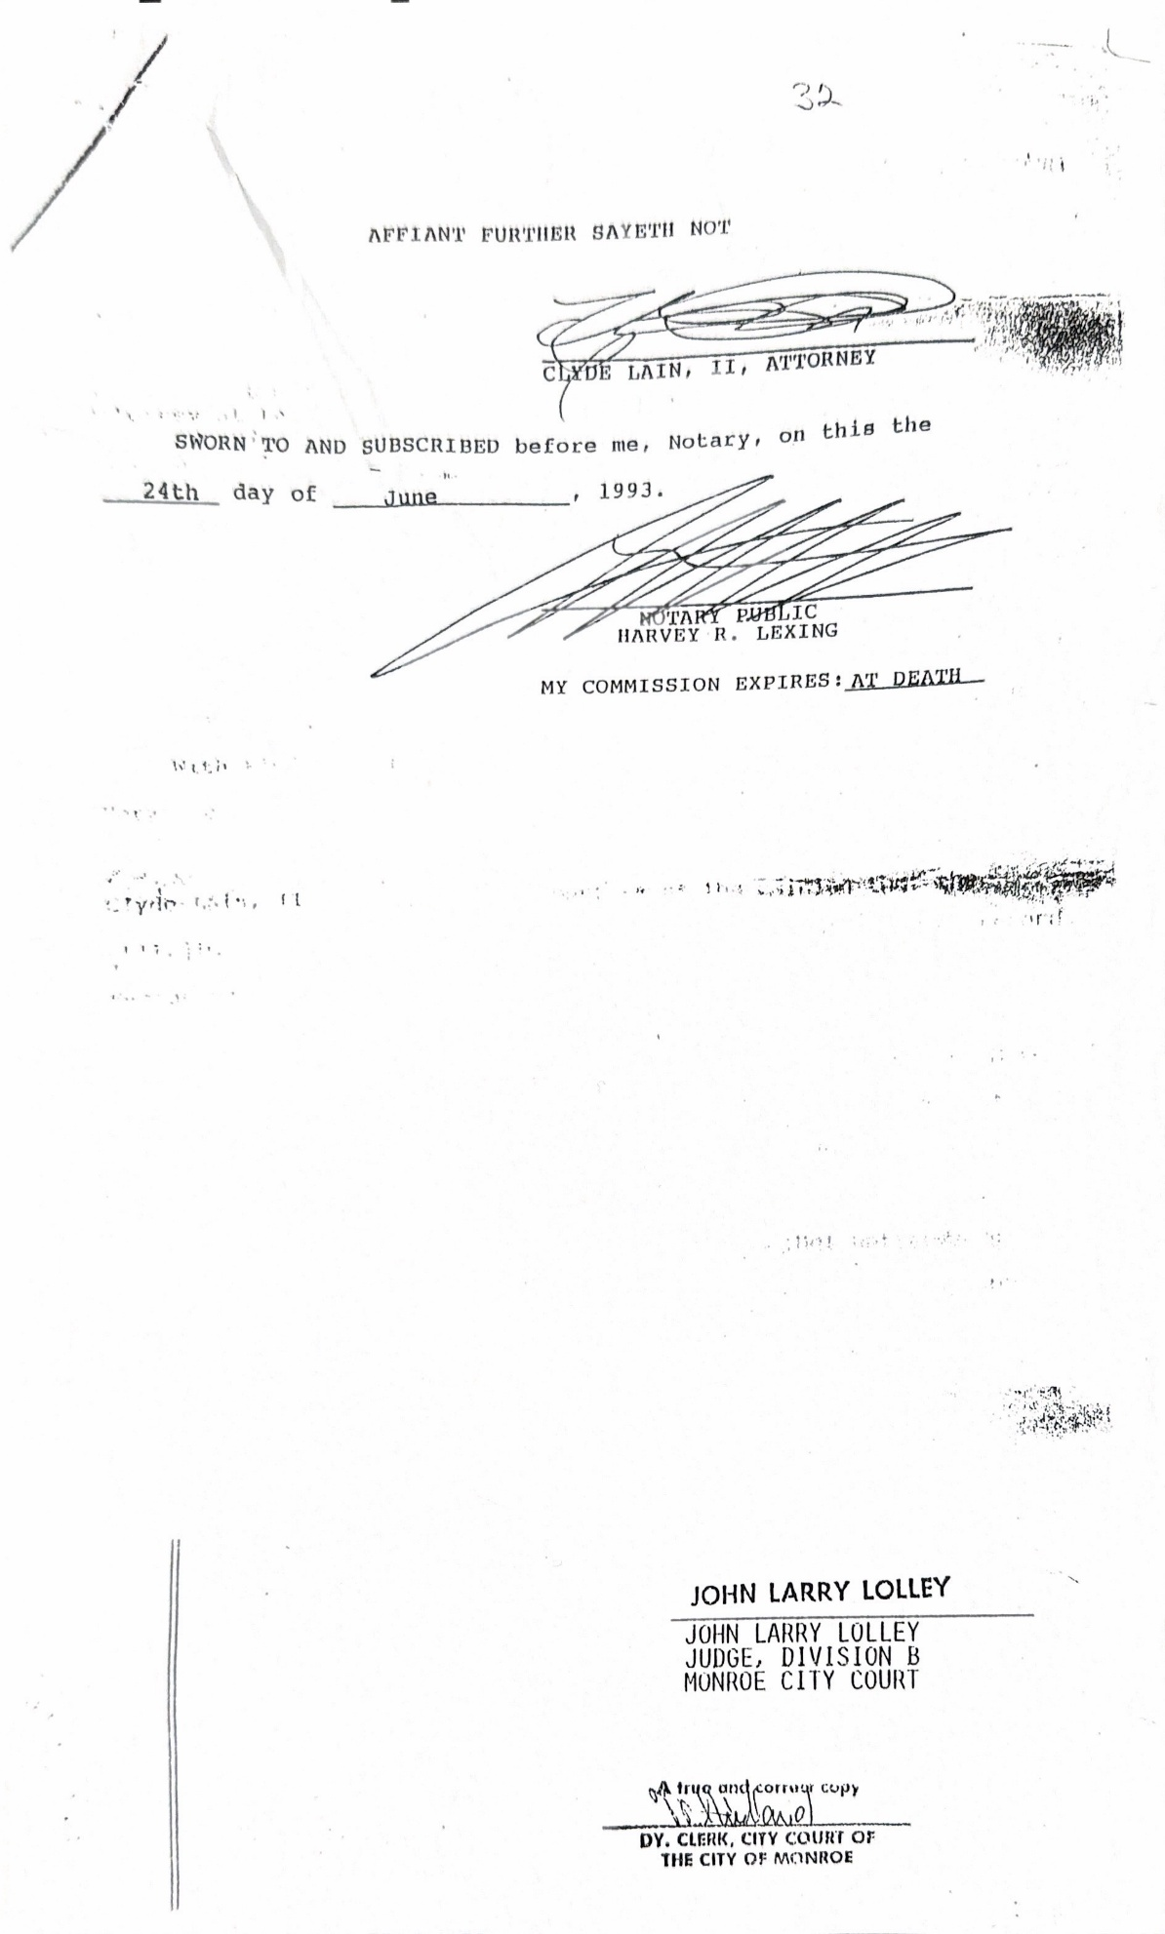

This is how Former Judge Larry Lolley, former City Attorney Carl Sharp, and Attorney Clyde Lain was able to take my case to court without me knowing anything about it. Case file # 8714142 & 8714690! The same file number is on Attorney Clyde Lain’s affidavit.
City of Monroe Versus Lester Paster, court was opened and presided over by the Honorable John Larry Lolley, Judge, on March 16, 1988. Attorney Clyde Lain appeared at arraignment session.
BY THE CLERK: LESTER PASTER. (I Lester Paster could not answer because I did not know about this court arrangement) BY MR. LAIN:” Good afternoon, your Honor, at this time, I would like to enroll as counsel of record for Mr. Paster; waive his presence and enter a plea of nollo contender to that charge, your Honor. BY THE COURT: As I understand it, the bulk of this situation has now been compromised between your client and the parties involved in this? BY MR. LAIN: yes sir. That’s correct. BY THE COURT: Ok. To the nollo, the court imposes a compulsory sentence of 10 days in jail suspended on terms of good behavior, combined disposition. BY MR. LAIN: THANK YOU, YOUR HONOR. (LOOK HERE) to see the secret trial.
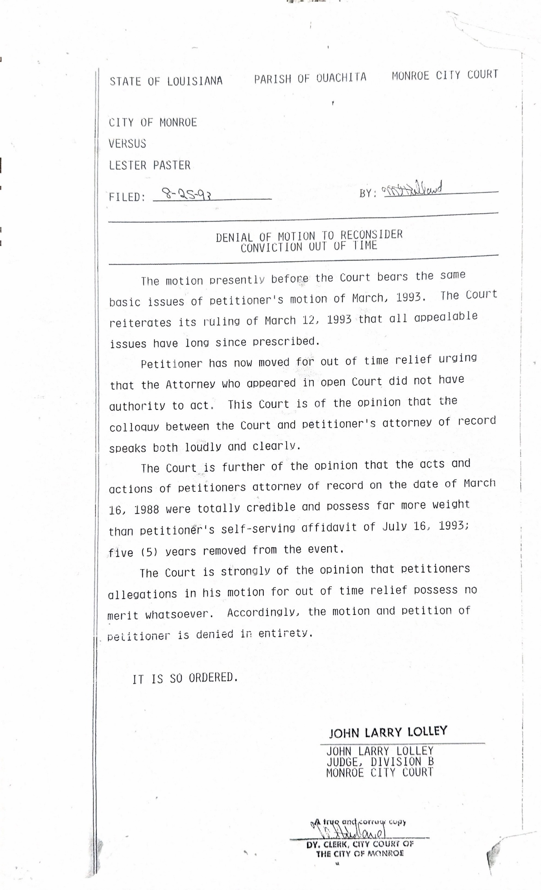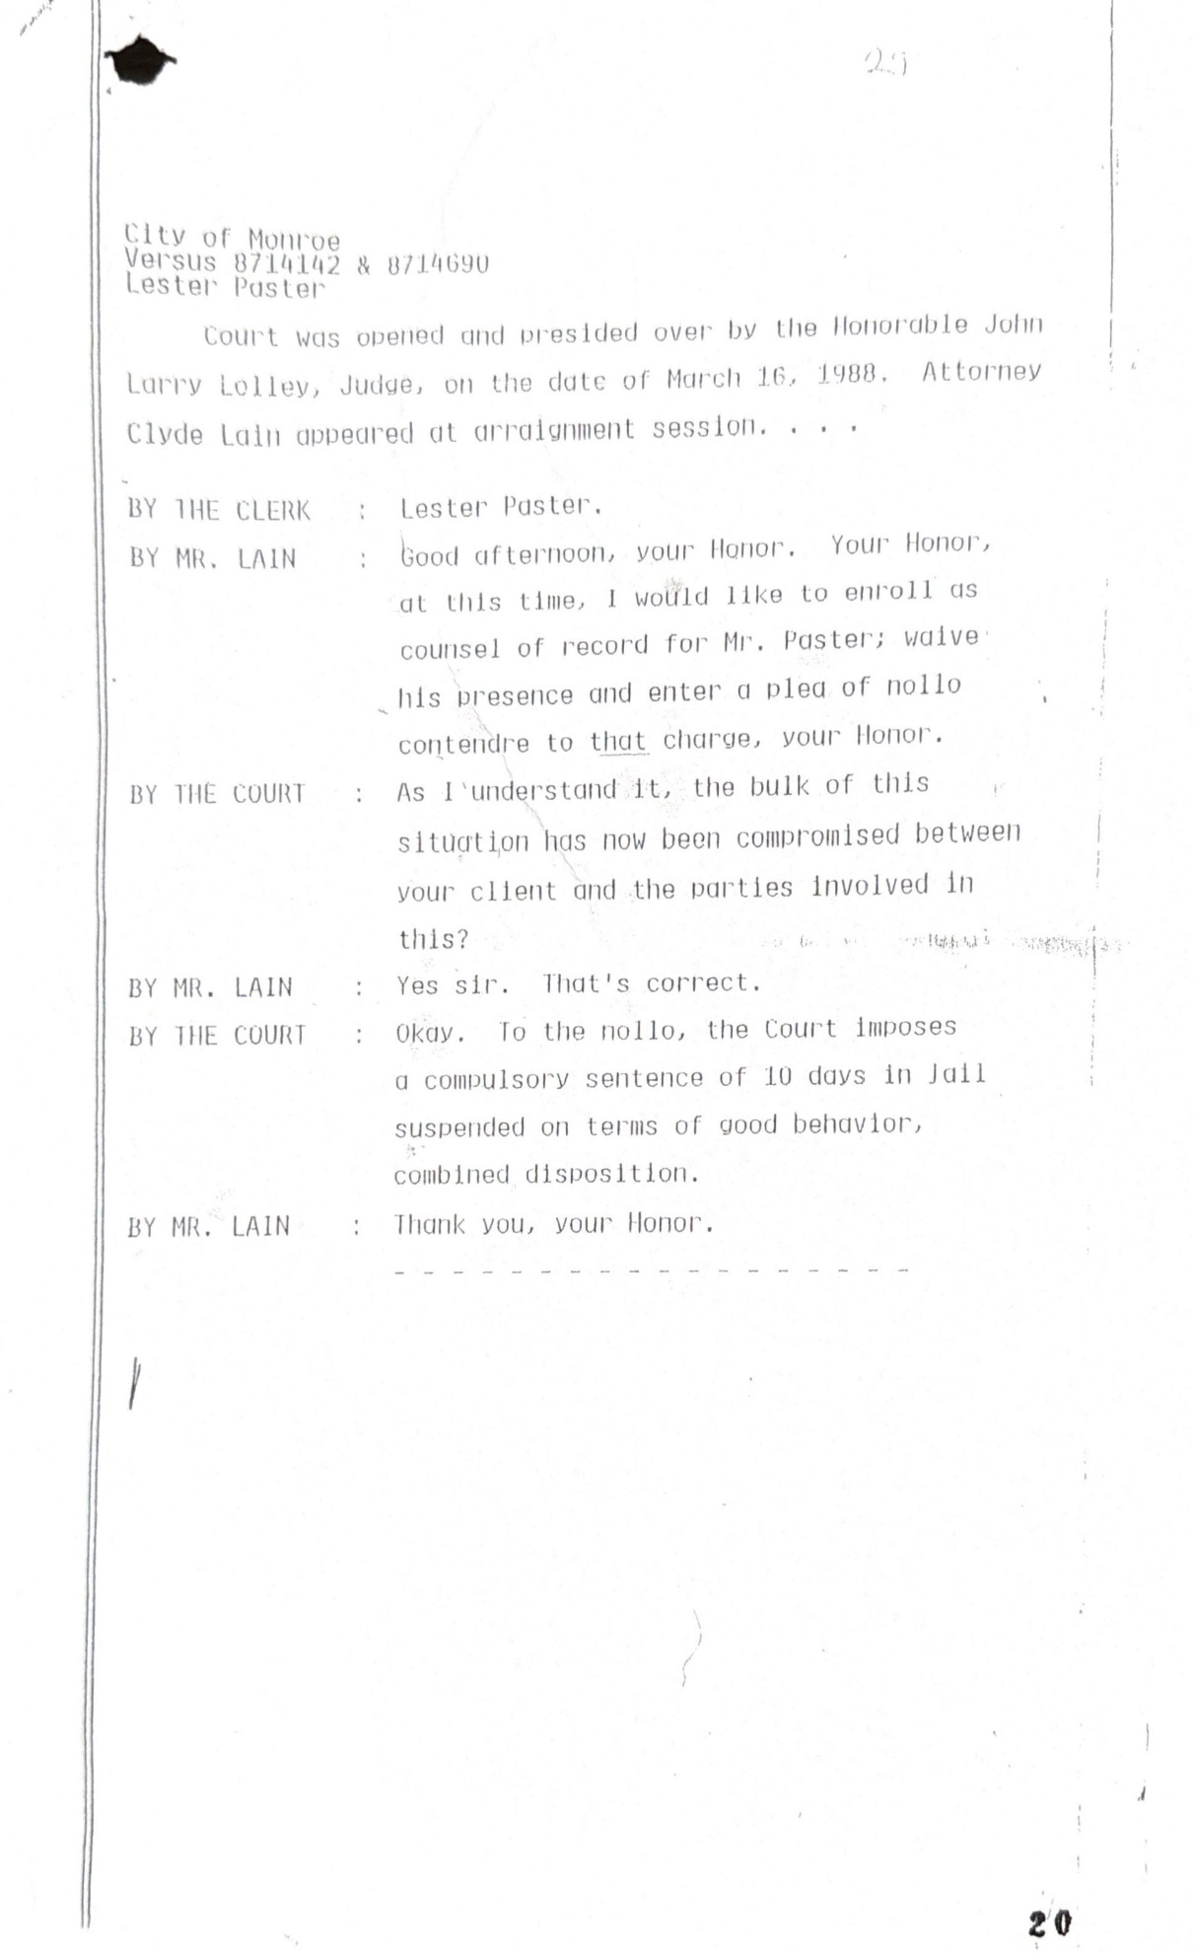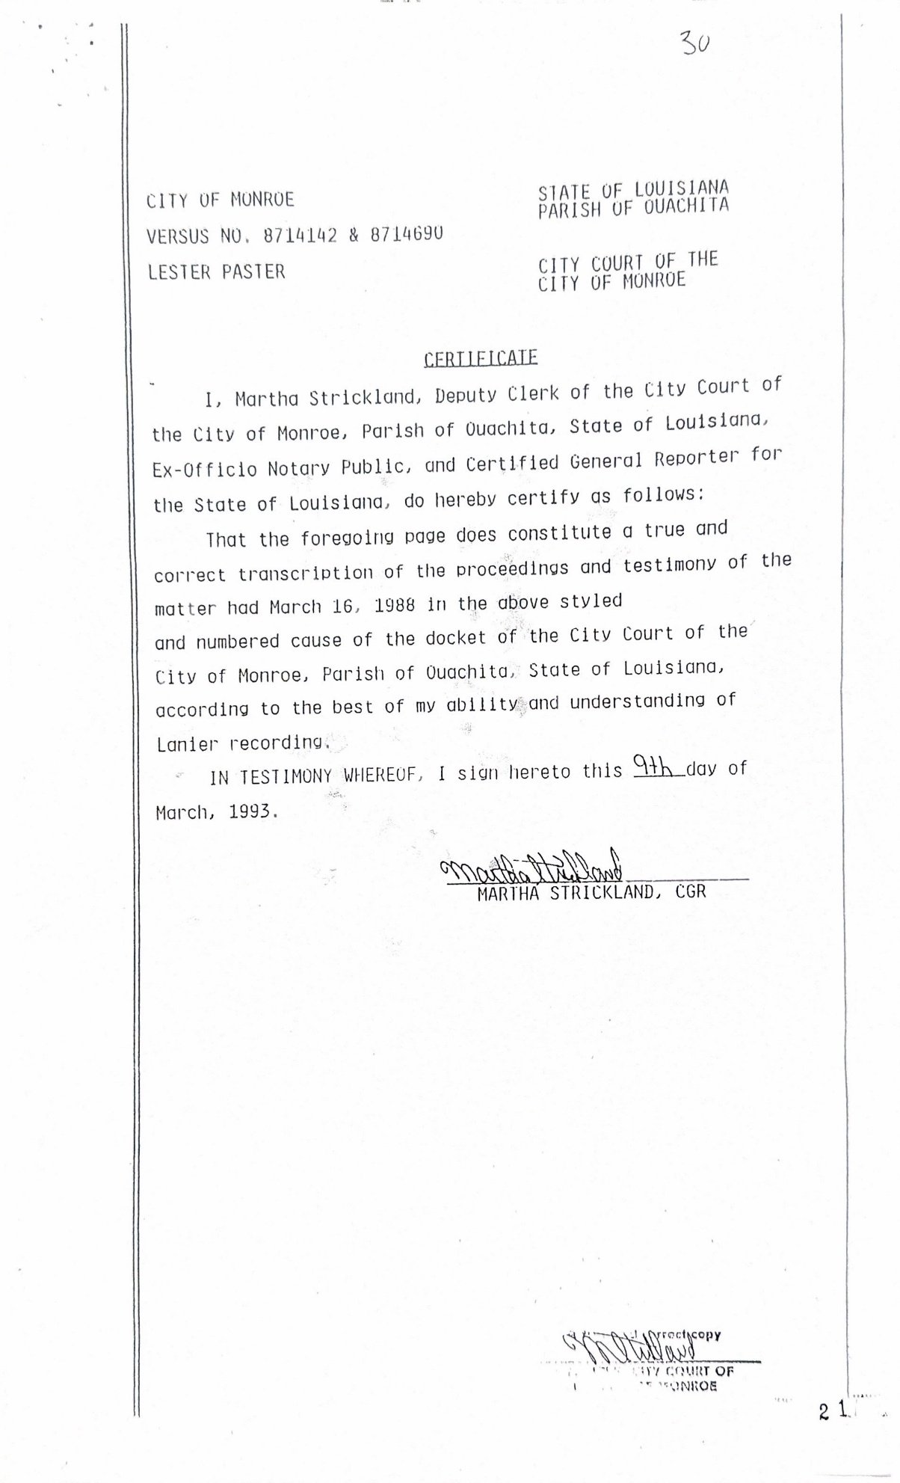
I need readers to know that this court arraignment in this case was held six months after the protest of the auto part store was over. To the nollo contender charger. That charge consists of three arrests, gagged with ammonia and an escape from jail.
I informed Louisiana Bar Association. That I never signed any documentation giving Attorney Clyde Lain the right to represent me. I sent in his affidavit to the Bar Association. The court case, that I paid twenty-five hundred dollars for. I sent all evidence to the Louisiana Bar Association. The Louisiana Bar Association refuses to hold Attorney Clyde Lain accountable.
FACT: Former Judge Carl Sharp needed this case to go away or be hidden. For him to be the first Black Judge, to be selected for the 4th Judicial District Court of Ouachita and Morehouse Parishes.
FACT: Fromer Judge Larry Lottey and I were in the Army Reserve together. There are some citizens who would have been uncomfortable voting for him, as Judge for Court of Appeal. If they had known that he teamed up with former Judge Carl Sharp and former Attorney Clyde Lain. In a Kangaroo Court. To violate my civil rights.
FACT: Rev. Garland Smith was trying to help friends who were wrong. There is no hate in my heart for you or anybody else, that is involved in violating my civil rights. Truth must be told.
I am a veteran who is asking the news media, public, and especially other Veterans for help. The Governor of Louisiana Jeff Landry and the Mayor Friday Ellis, of Monroe La. Are veterans also. I am asking that we inform both, that we are against this type of court room behavior, and we are asking for an investigation of these cases.
It is wrong to turn a blind eye to injustice. No one is above the law. We should never collaborate with those who are violating the law. Senator Katrina Jackson, State Representative Pat Moore, Monroe City Council Verbon Muhammad, and other State politician. I am asking that news media, and public, demand that you honor your oath of offices also.
City Council meeting, held on Feb 25, and March 11, 2025. I made it known that I had a meeting with, Monroe City Attorney Mr. Brandon Creekbaum and Bishop Cliff Thomas, the president of the NAACP. The City Attorney Mr. Brandon stated that he calls former City Attorney Nanci Summergill and asks about the dismisses of the order of Court of Appeal. He stated she admitted to dismissing the order of Court of Appeal. Then stated, Miss Summergill does have the right to dismiss the order of Court of Appeal. He tried to google the law, to show us that she does have the right to dismiss the order of Court of Appeal. But he was unable to find the law that allowed her to dismiss the order of Court of Appeal.
City Attorney Brandon Creekbaum also stated in that meeting that regardless of whatever I do, I will not be locked up. If I do get lockup, the case is not going court, if it goes to court a Judge, is not going hear it. This was stated Infront of the president of the NAACP.
There is nothing on file, in the Monroe City Clerk of Court Office, that verifies the order of Court of Appeal has been dismissed. It is just what they say. The City Attorney Mr. Brandon stated to the president of the NAACP and I that he was told that either a pipe busted and destroyed, the Order of Court of Appeal, or the order of Court of Appeal got burnt in the fire.
I also had a meeting on June 10, 2025. With Monroe City Attorney Brandon Creekbaum, City Council Bishop Rodney McFarland, and Council Miss Juanita Woods. Mr. Creekbaum presented a document to the City Councils and I. Filed: On 09/27/16. Before: CARAWAY, LARRY LOLLEY, who has now been elected to Court of Appeal, and PITMAN, JJ. Council Rev. Bishop McFarland new something was wrong when he saw Judge Larry Lolley name on the document.
MOTION DENIED. The applicant, Lester G. Paster., has filed a motion complaining that his case, arising from an1997 charge for a violation of La. R.S. 14:401, is not proceeding as ordered by this court’s opinion in City of Monroe V. Paster, 97-30856 (La. App. 2d Cir. 9/23/98), 737 So. 2d 965, whereby this Court vacated the applicant’s conviction and remanded the matter to the Monroe City Court for new proceedings. Contrary to the applicant’s arguments, on remand from this Court, the prosecutor for the City of Monroe had the authority to dismissed, the case is final and the applicant is not entitled to a new trial. (Look Here)
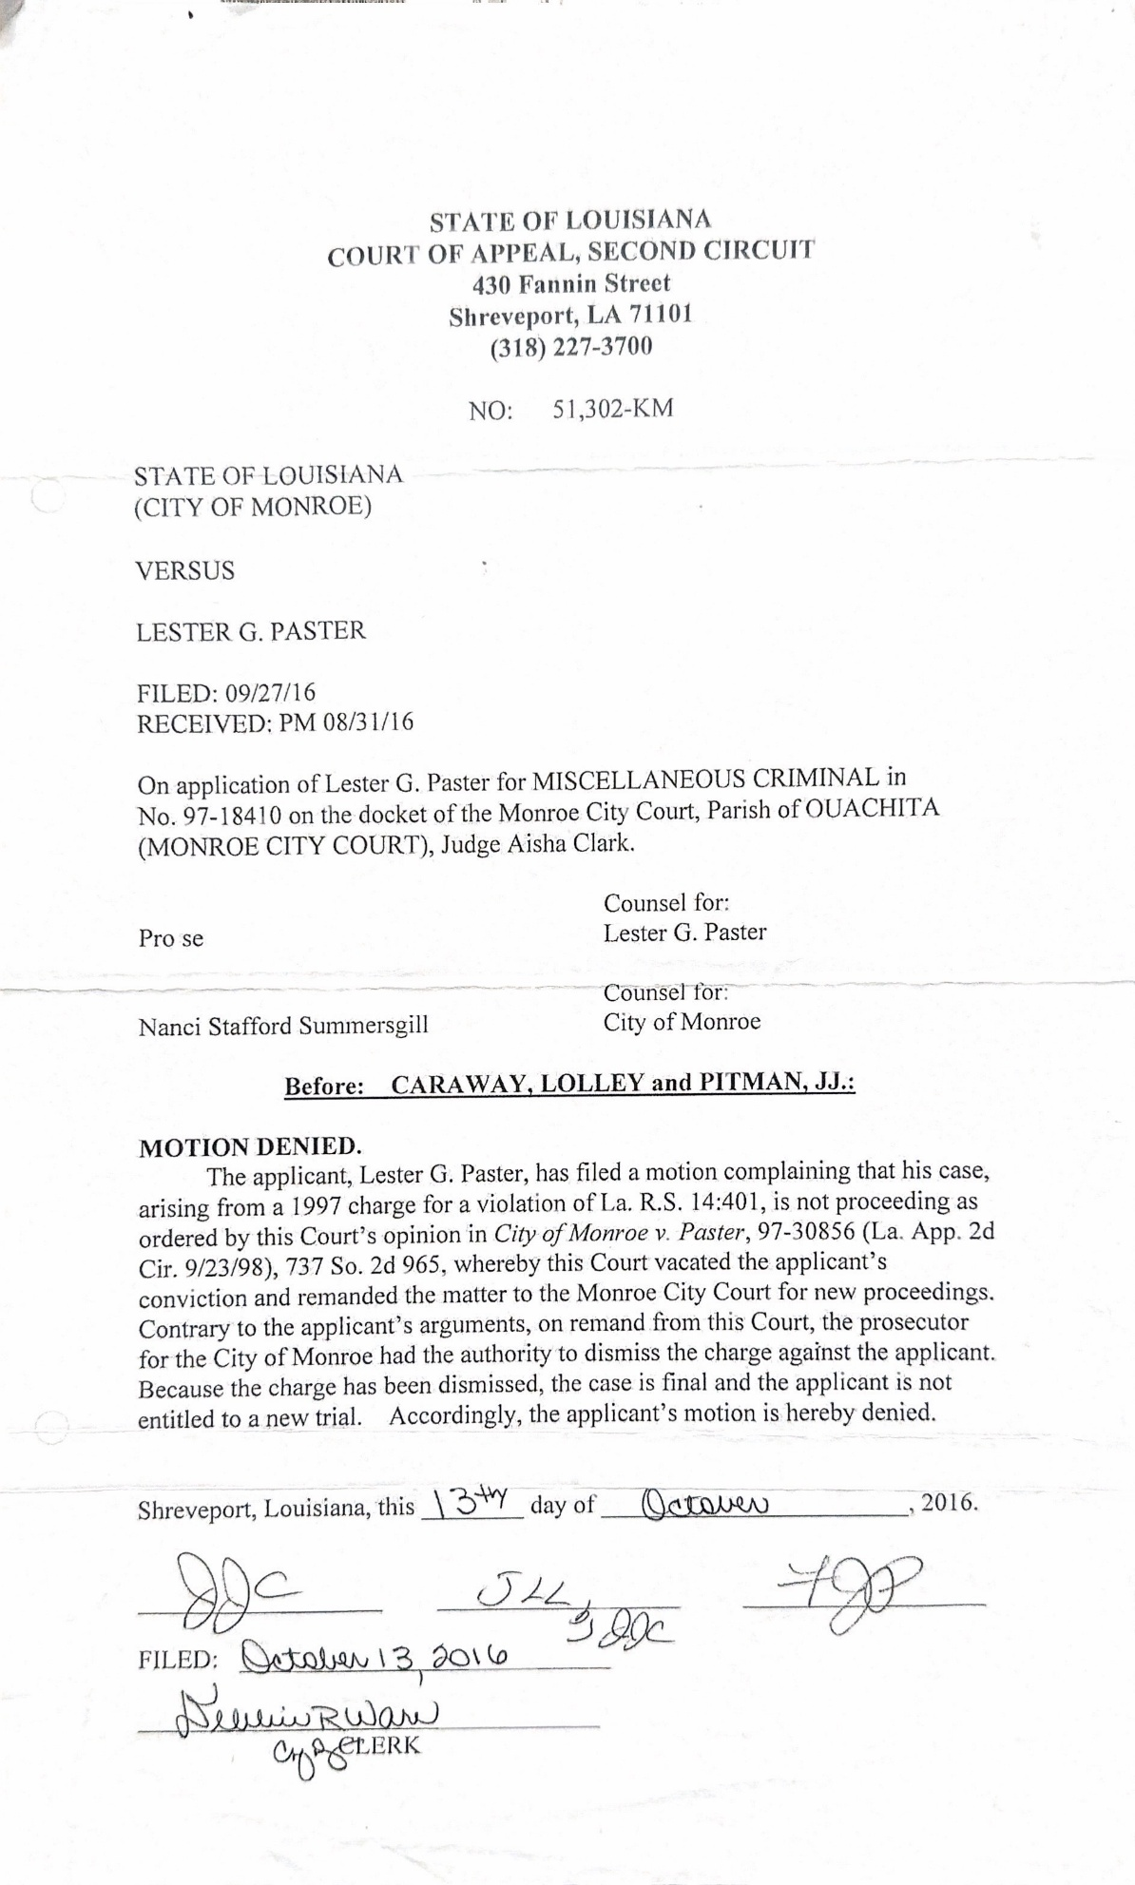

On June16,2025. I inform the Court of Appeal. About the meeting we had with Monroe City attorney Brandon Creekbaum, council McFarland and council Miss Woods. I am requesting what Acts or statute gave former city attorney Nanci Summersgill the authority to dismiss the order of Court of Appeal. Case No. 30.856-KA. The judgment was rendered on September 23, 1998.

Court of Appeal did not inform me of what Act or Statue gave former city attorney Nanci Summersgill the right to dismiss the order of court Appeal Court. The Appeal Court words are clear; I was charged with La.R.S. 14:401. Again, this is not a city charged, (Look Here)
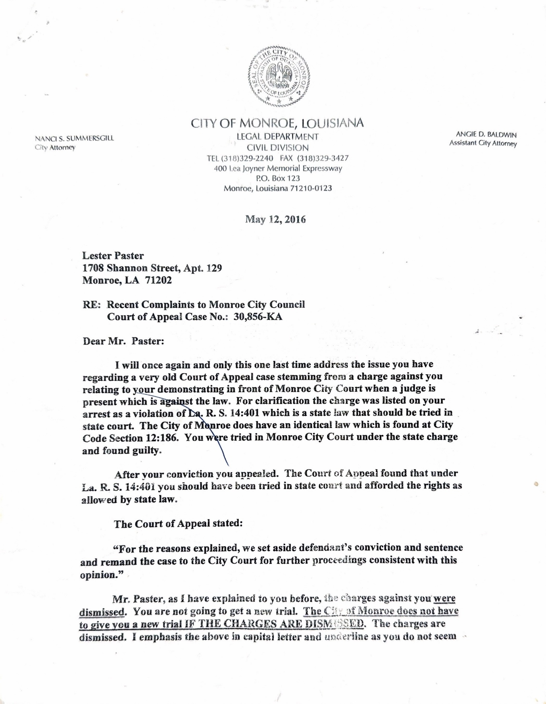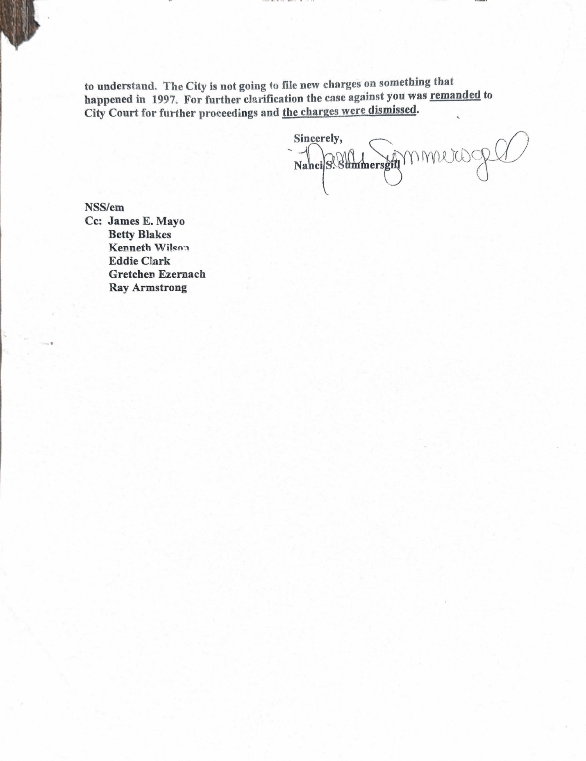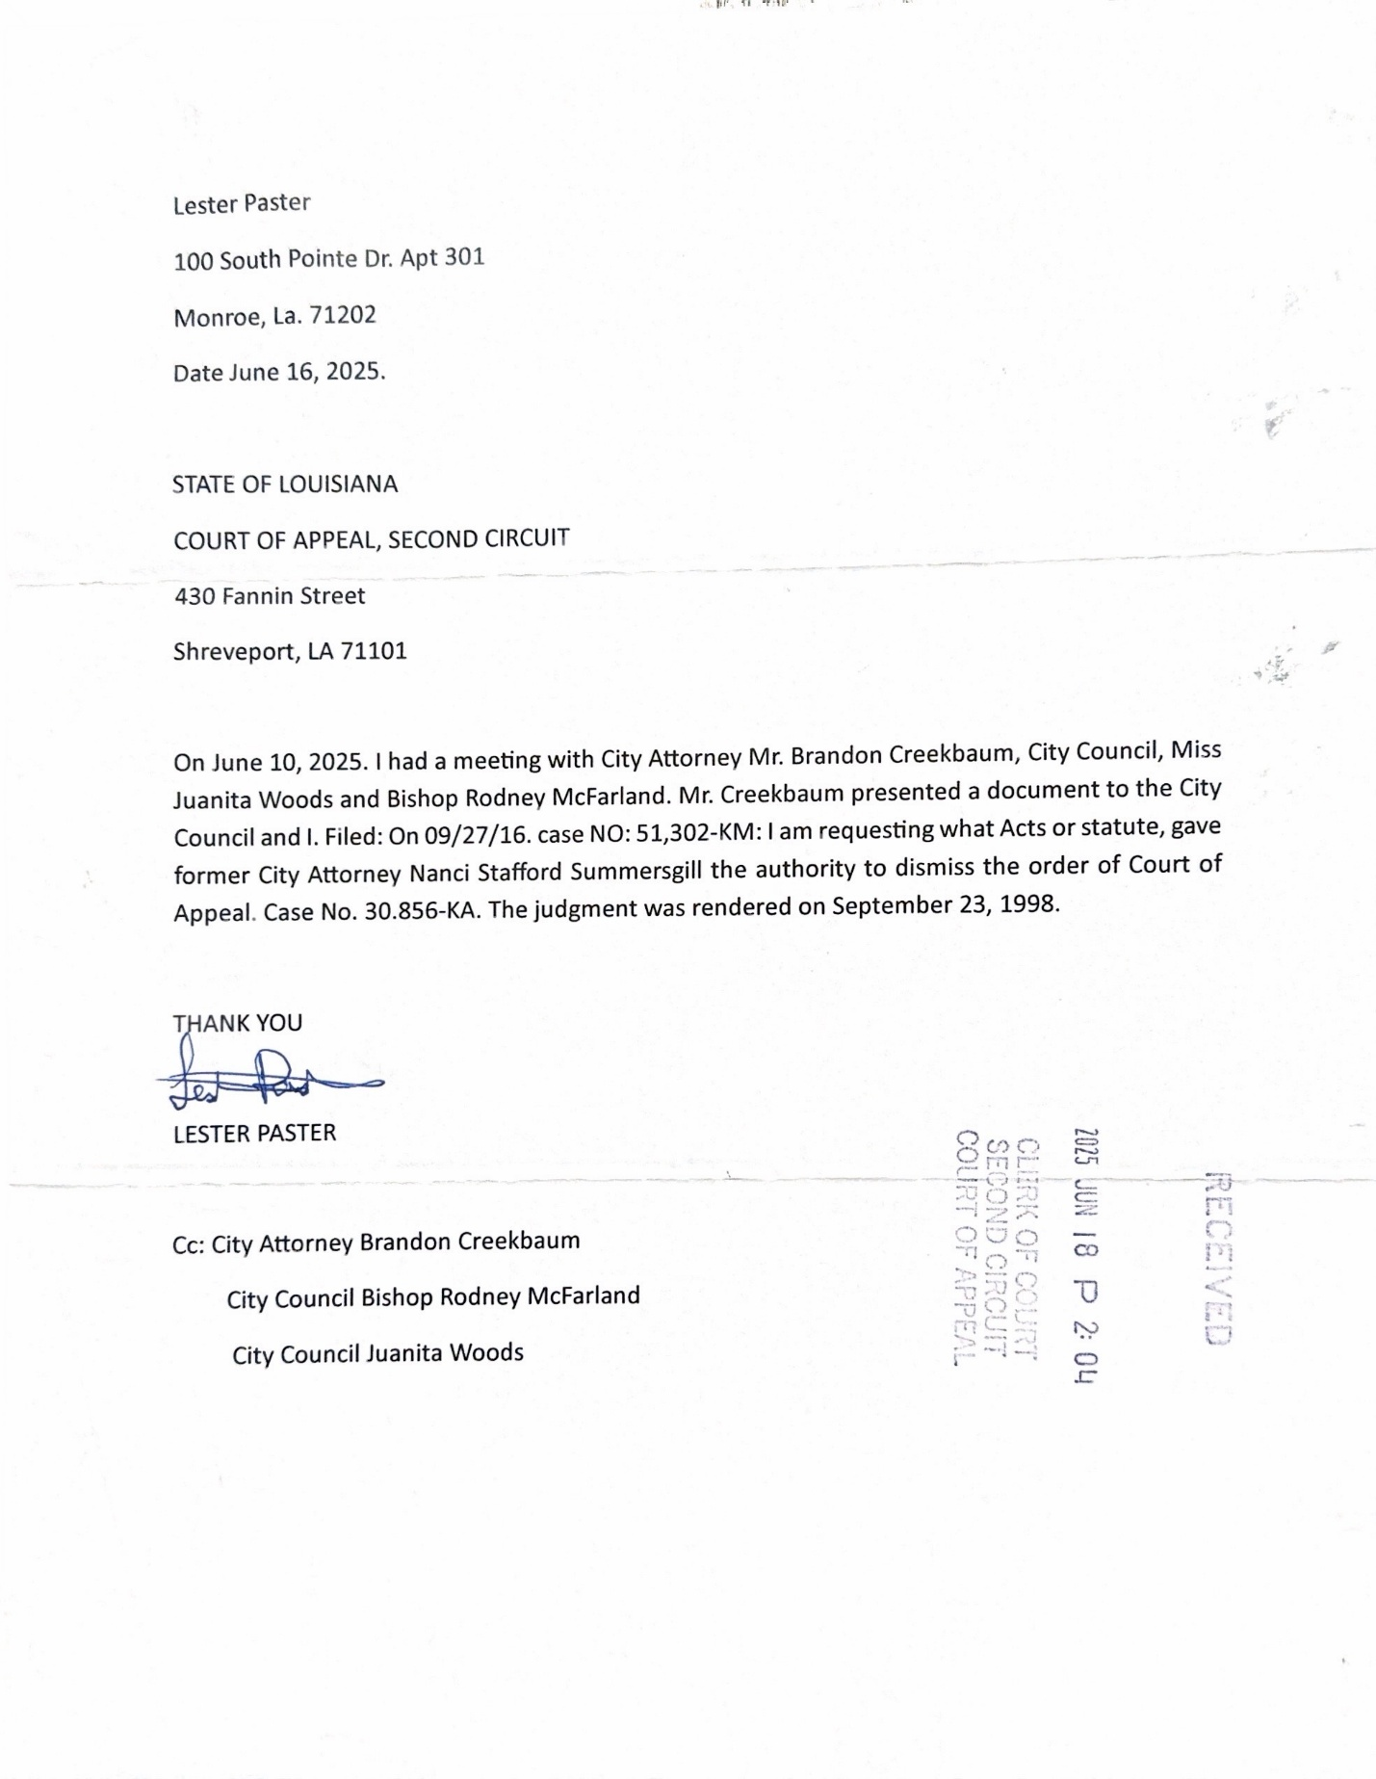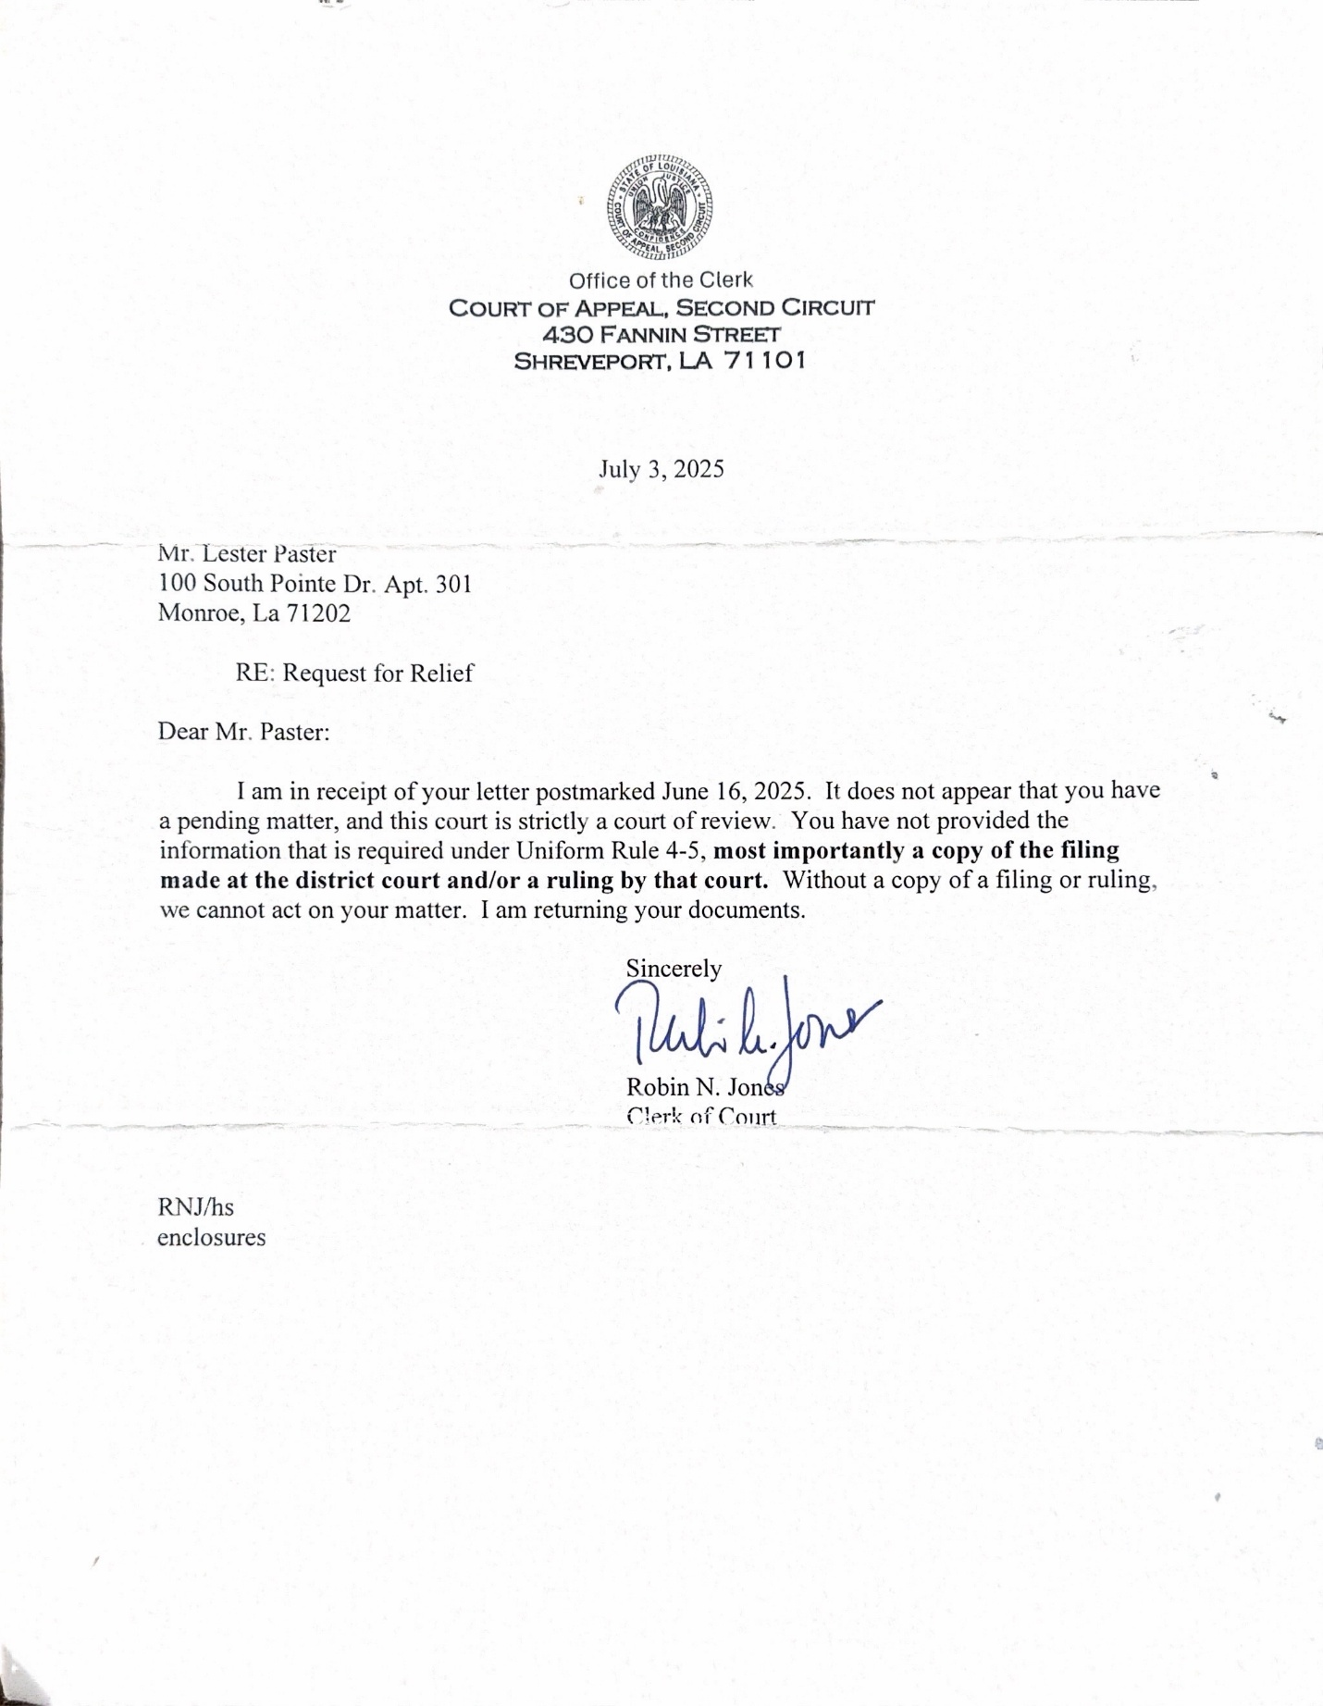
Court of Appeal dated July 3, 2025, added more insult to the injury. I am a 72-year-old Veteran. Robin N. Jones, Clerk of Court of Appeal, returned documents that informed me about uniform rule 4-5. The order of Court of Appeal clearly states that I have the right to counsel and a jury trial. I would rather for my counselor, whom I haven’t received, deal with uniform rule 4-5 and any other rule required for this Court of Appeal to be carried out.
Please contact our Governor, Monroe City Mayor, and local politicians informing that we would like to see an investigation of this case.

Thank You, Sincerely Mr. Lester Paster

